  3. Think about the structure and organisation of the text-what it looks like.  How do headings help you when you scan the text?  How does the layout help the reader?  How does the title of the story encourage you to read more?  How does the story blurb on the back cover encourage you to read the book? What things do you now want to find out after reading the blurb?  Some of the text is printed in a different way, why do you think the writer does this?  Why has the author repeated structures, words and phrases?  What is the purpose of the pictures?  What is the purpose of a caption?
  4. Explain and comment on the writer’s use of language-including grammar features.
  What does (word/phrase) mean?
  Which words has the author used to make the writing sound more formal/informal?
  Why has the author used …. (italics, bold, exclamation marks, headings, bullet points, captions etc.)
  What has the author used in the text to make the characters sound funny/sad/angry?
  Think of another word you can use here. What different effect would your word have?
  As a reader, how do you feel about this character? What makes you feel that way?
  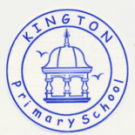 |  | Kington Primary School  Mill Street, Kington, Herefordshire, HR5 3AL
  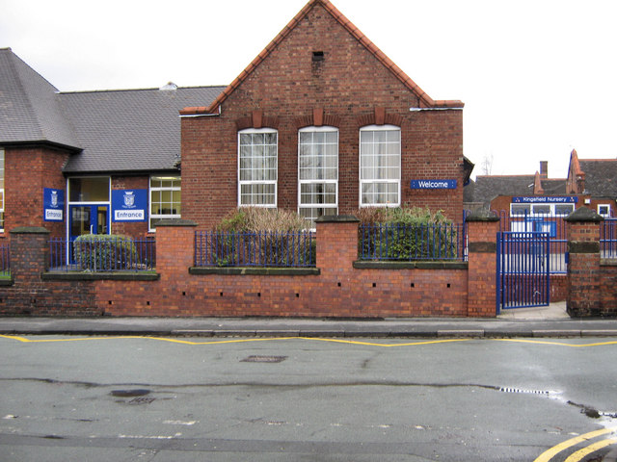
  Kington Primary School
    - How to help your child with reading
    - Reading questions for parents

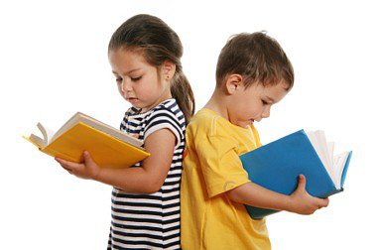  - I can understand, describe, select or retrieve information events or ideas from texts using quotations.  Where does the story take place?  When did the story take place?  Can you describe the character’s appearance?  Can you predict what the story may be about the title?  Where do the characters live?  Who are the main characters?  What happened in the story?  Can you describe the problem in the story? How would you solve it?  Can you identify words that describe the setting or character?  What happened after….?  Can you tell me why….?  Look at the picture of the character, how do you think they are feeling? Why might this be?  Describe what happened at/when.  What do you think will happen next?  What did the character say to….? |  |  | What happened in the story?  Can you describe the problem in the story? How would you solve it?  Can you identify words that describe the setting or character?  What happened after….?  Can you tell me why….?  Look at the picture of the character, how do you think they are feeling? Why might this be?  Describe what happened at/when.  What do you think will happen next?  What did the character say to….?  - I can deduce, infer and understand information from the text that I am reading.  What does the word … imply/make you think of?  If you were going to interview/ask a character a question-who would you ask and what would your question be?  What do you think will happen because of ……? |  |  |   Through whose eyes is the story told?  Why do you think … feels…?  If this was you, what would you do next?  How have the characters changed during the story?  Predict what you think is going to happen next. What makes you think this?  How do you know that…? (Deduce/Infer)  What does the main character feel at this point in the story? How do you know this-can you pick out a sentence?

