Year 1 Reading Spine
Archaic Texts

The Ugly Duckling by Ian Beck (Other versions also available in class)  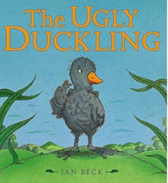 | The Cat in the Hat by Dr Seuss (other Dr Seuss Books also available)  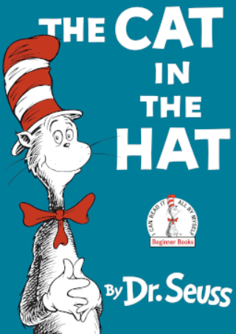 | Where the Wild Things Are by Maurice Sendak  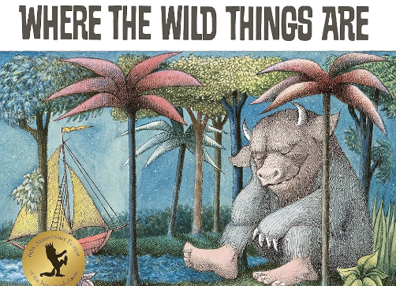 | Also available in class; other traditional tales and nursery rhymes, Aesops fables, The Night Before Christmas Poem, The Tale of Peter Rabbit, The More it Snows by AA Milne
Complexity of the Narrator

The true story of The Three Little Pigs John Scieszka  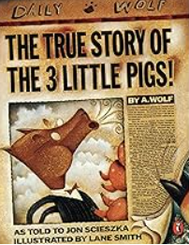 |  | The Three Little Wolves and the Big Bad Pig Eugene Trivizas  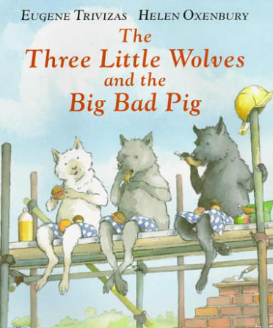
Complexity of Plot/Symbol

The Tiger Who Came to Tea Judith Kerr  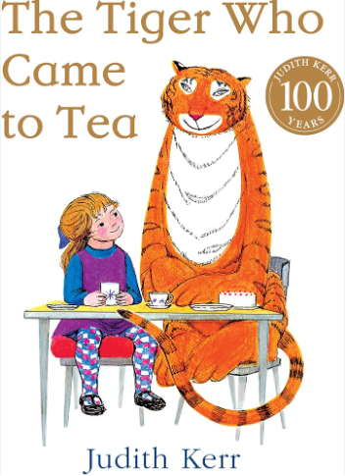 |  | Owl Babies Martin Waddell  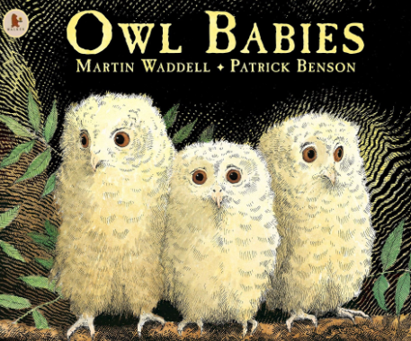
Resistant Texts

Lost and Found Oliver Jeffers  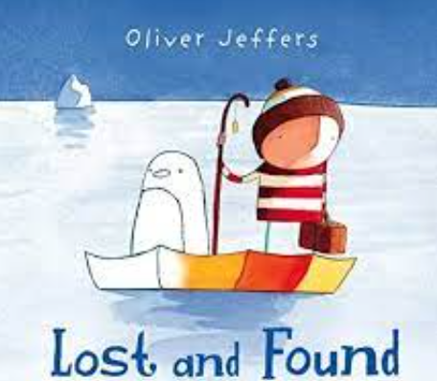 | The Colour Monster Anna Llenas  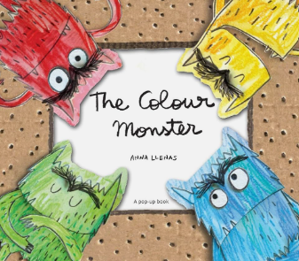 | Not Now Bernard David McKee  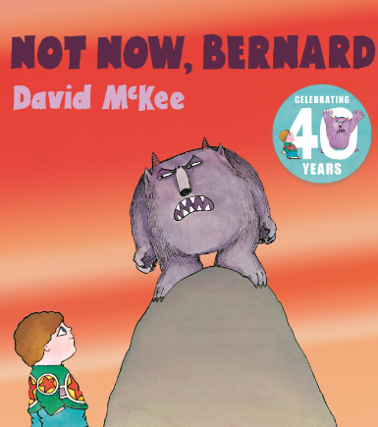 | How to Heal a Broken Wing by Bob Graham  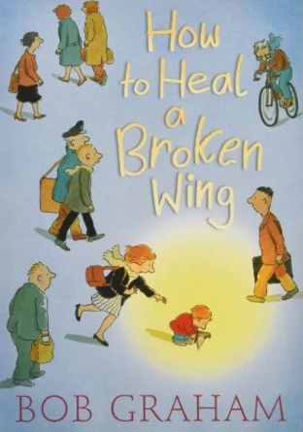
You Choose by Nick Sharrett  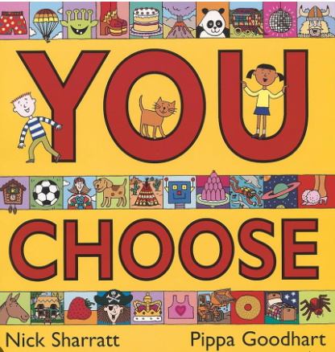 | This is our House by Michael Rosen  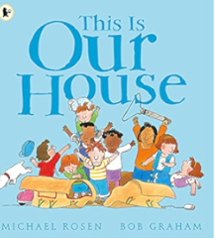 | Stanley’s Stick by John Hegley  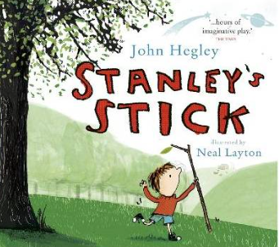 | Beegu by Alexis Deacon  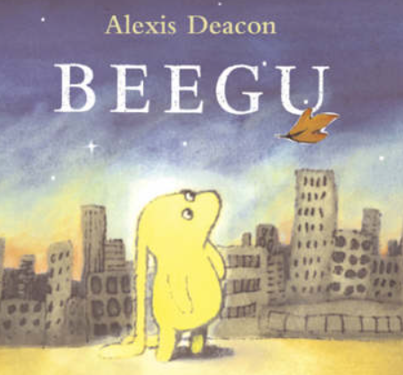
Mama Panya’s Pancakes by Mary and Rich Chamberlin  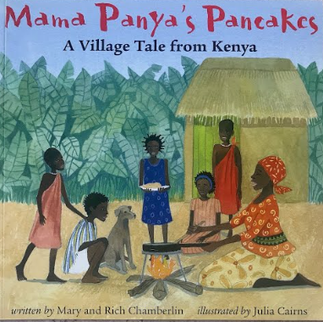 | Knuffle Bunny by Mo Willems  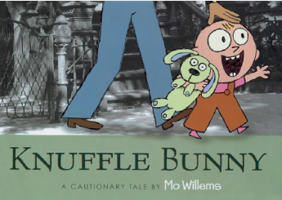 | The Snail and the Whale by Julia Donaldson  

