Kington Primary Nursery – Summer Learning Activities
Here are some reading activities for Nursery children to try over the summer. Have fun!
Read outside on a sunny day   | Read to a pet or a soft toy   | Look at a book in the car or on the bus   | Read a book while eating a snack   | Read a fairy tale  
Read a book and then draw a picture of one of the characters  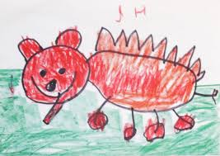 | Read in bed   | Reading Bingo | Read in or under a tree   | Look at the pictures in a book and tell the story to your grown up  
Read two books, one after the other. Which do you like the best and why?  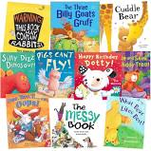 | Read a book about animals  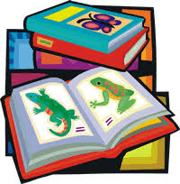 | Read a book that makes you laugh   | Read in the dark, using a torch to see the pages   | Make a den and read inside  

I would love to see photos of your activities on Tapestry!

