Kington Primary Nursery – Summer Learning Activities
Here are some outdoor activities for Nursery children to try with their family over the summer. Have fun!
With help from your grown up, use a potato peeler to whittle bark from a stick. Draw a face on it to make a stick creature!  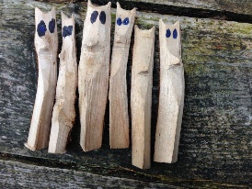 | Go on a barefoot safari! Walk barefoot in your garden or on a beach. What does the ground feel like?  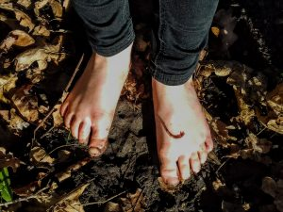 | Try wearing a blindfold for part of a walk in the woods or countryside. What can you hear, feel or smell?  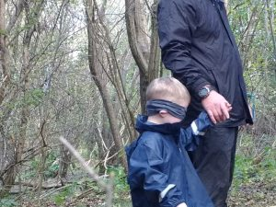 | Go cloud gazing! Lie on your back and look up at the clouds. What do they look like?   | Have a picnic outside. Help to make and pack the food you will eat.  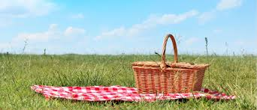
Make a bow and arrows using sticks and string. Can you shoot an arrow?  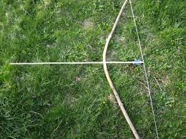 | Build a den ourdoors or in the woods. How many people can hide inside?  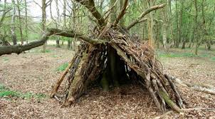 | Outdoor Learning Bingo | Be an explorer! Go for a walk with your family somewhere that you have never been before. What did you discover?   | Find somewhere safe to have a paddle with your family. Did you go to the beach, visit a river or play in a paddling pool in your garden?  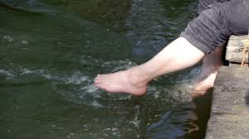
Make some mud pies or fairy potions with leaves and petals mixed with water.  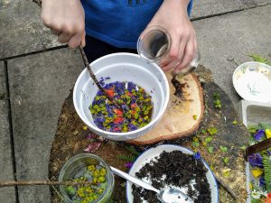 | Try to make your own paint by mixing crushed charcoal or spices with water or by squashing up berries.  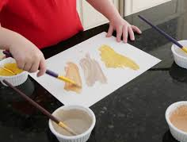 | If you visit a beach or a river, see if you can collect some pebbles or shells. Can you find different shapes and colours? Take your favourite one home to remember your outing.   | Can you find any ripe blackberries to pick in the hedgerows? Maybe you could take a handful home to eat?  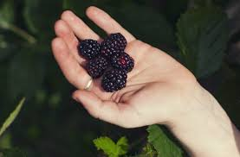 | Find somewhere outdoors to play hide and seek with your family. Where did you hide?  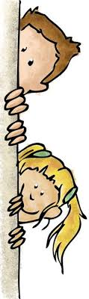

I would love to see photos of your activities on Tapestry!

