Kington Primary Nursery – Summer Learning Activities
Here are some wellbeing activities for Nursery children to try over the summer. Have fun!
Make a sensory box or bag and fill it with things that feel nice e.g. a smooth pebble or a soft toy  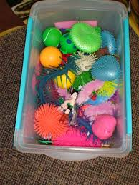 | Try some yoga – get a grown up to search for ‘Cosmic Kids yoga’ or ‘Yoga with Georgie Treasure’   | Do some exercise with someone in your family. Try an online workout, ride your scooter or play outside   | Ask your grown up to help you use their phone or camera to photograph flowers or trees. How many different ones can you find? Which did you like the best?   | Make a healthy snack to eat  
Sit outside or by a window. Be quiet for one minute and see what sounds you can hear   | In your garden or on your daily walk, try to find some scented plants and flowers. Smell them!   | Wellbeing Bingo | Think about all the special people in your life and draw a family portrait   | Grow a lavender plant in your garden or on your windowsill. Use the flowers to make a lavender bag  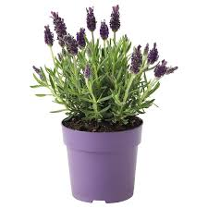
Try a ‘unplugged day’ in your house. Turn off the telly, phones and tablets and talk and play with your family   | Enjoy some sensory play with shaving foam, jelly, cornflower goop or rice  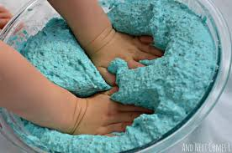 | Go for a walk with your family in a park or in the woods. What can you see? What natural treasures can you find?   | Have a lovely long cuddle with someone you love   | Listen to some happy music and sing along as you dance around the room!  

I would love to see photos of your activities on Tapestry!

