Kington Primary Nursery – Home Learning Activities
Here are some activities for the Nursery children. Try one or more each day and repeat some of them throughout the week, if appropriate, to consolidate learning. Have fun!
Read the story of the Three Little Pigs:  https://www.youtube.com/watch?v=JDYfnfUuD00  Why not make a den with your grown up indoors or in your garden? The pigs used straw, sticks and bricks to make their houses. What could you use to make your den?   | Read the story of the Three Bears:  https://www.youtube.com/watch?v=Rm3JsewQIWw  Have a look around your house and try to find different sized objects for the bears e.g. a big sock, a middle-sized sock and a large sock (or bowls, or spoons, or t-shirts or shoes)  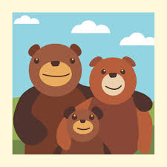 | Read the traditional tale of Anansi from West Africa:  https://www.youtube.com/watch?v=NMBnKh5LS7E  The pictures in this story are made up of shapes. Cut some shapes out of coloured paper or an old magazine and see if your child can use them to make a shape picture. Talk about the names of the shapes.  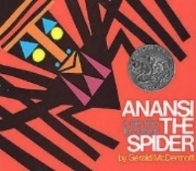 | Read the story of the Three Billy Goats Gruff:  https://www.youtube.com/watch?v=xNJBzcqjIYw  Can you act out the story with your grown up and join in with the repeated refrains? Can you find a blanket or sheet to be the river? Can you find something in your house to make a bridge that you can walk over?  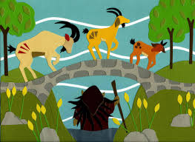 | Read the Aboriginal Tale of Tiddalik from Australia:  https://www.youtube.com/watch?v=CAUNMOClMRE  We looked at Aboriginal Art at Nursery and made some dot painted letters. If you have some paints, you could try a dot painting at home – if you do not have paints, follow the paint recipe and make your own!. Use your fingers or a cotton bud to make dots.  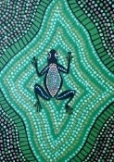
Dance along to Dance ‘n Beats Lab ‘Knock Knock’ dance:  https://www.dailymotion.com/video/x5xivs7  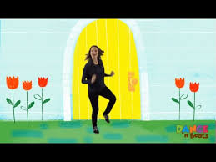 | Read the story of The Frog Prince:  https://www.youtube.com/watch?v=BE4nLIkBQxw  Practise ball skills by rolling, throwing and catching balloons or large balls.   | Traditional Tales | Read The Great Race, a traditional tale from China:  https://www.youtube.com/watch?v=eVClAj8q_lY  Play ‘Magic Animals’. Your grown up needs to pretend to wave a magic wand and turn you into one of the animals from the story. Move about the room like that animal and try to make the sound it makes. | Read the story of Jack and the Beanstalk:  https://www.youtube.com/watch?v=oyYh43hxSts&t=59s  Try this yoga session based on the story:  https://www.youtube.com/watch?v=SKC_Lgvukv0
Read The Princess and the Pea:  https://www.youtube.com/watch?v=7V1jAr3xOlk  Can you stack bricks or blocks (or even books) up to make a tall bed for the princess to sleep on? Try counting the bricks - up to 5 and then up to 10 and beyond.  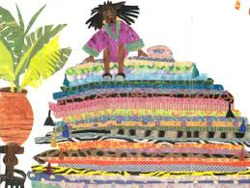 | Make a sparkly fairy name sign for your bedroom door. Get your grown up to write your name in large letters with pencil on a piece of paper. Use glue and sequins, scrunched up tissue paper or little bits of tin foil to decorate it.  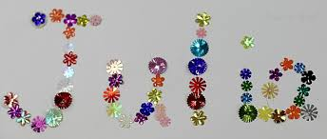 | Read the story of Chicken Licken:  https://www.youtube.com/watch?v=VzbHLQDNaMY  In the story the characters all have rhyming names. Can you make up some funny rhyming names for the people and pets in your family e.g. mummy gummy, daddy waddy?  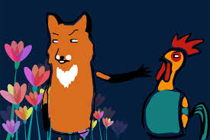 | Read the story of the ugly duckling:  https://www.youtube.com/watch?v=v_FpxF8z3Kg  Use this story to talk to your child about feelings and how unkind words can make us feel sad but kind words can make us feel happy. You could also talk about how everybody looks different and that is what makes all of us special.  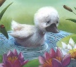 | Read the story of the Gingerbread Man:  https://www.youtube.com/watch?v=H0uV6nWxO-w  Make your own gingerbread men (if you do not have a gingerbread man cutter, use the rim of a glass to cut out circles and make biscuits instead)  https://www.persil.com/uk/dirt-is-good/recipes/make-your-own-gingerbread-men.html
I would love to see photos of your activities on Tapestry!

