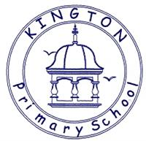

We felt that it was important to share the following information about reading and phonics with you and we hope that you find it both interesting and informative and helps you to understand some of our approaches used across school.
Reading is Fundamental
Reading develops the brain, provides a window into the world around us and helps children to access and understand other curriculum areas throughout their time in education.
Across school we continue to promote and develop the range and richness of vocabulary which our children can use with understanding and purpose and the approaches of both T4R (Talk for Reading) and T4W (Talk for Writing) support this brilliantly alongside our ‘word of the day’ resources used throughout KS2.
The types of activities which T4R promotes and that you will be able to see elements of in all of our classes include: -
Whole class and /or group reading sessions which support the development of answering all question types effectively.
Regular opportunities to read 1:1 with an adult,
Promotion within classrooms of a genuine love for and engagement with reading a wide variety of text types but to also be able to articulate what they enjoy as a reader.
Engagement with class texts which are based on Pie Corbett’s reading spine with books chosen to develop enjoyment, vocabulary and an awareness of high-quality texts and authors. https://shop.scholastic.co.uk/reading-spine

Reading for pleasure
Here at Kington we really want to develop a love for literature. We aim to encourage reading for pleasure through our class stories, having a good variety of text types accessible to all in each classroom, termly visits/book loans from the Herefordshire library van, opportunities to buy from the £2 book fair which we hope to have visiting us at least twice a year, whole school reading challenges and time to read with our friends.
Reading for pleasure is when children read greedily with passion, talk about books with their friends recommending good reads to each other and see themselves as ‘readers’.
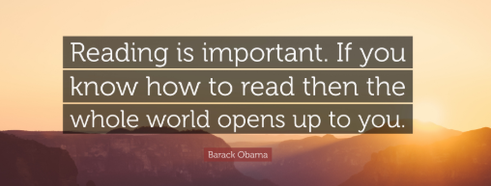
Phonics is of huge importance
Phonics is a high priority at Kington and teaching of this begins in our Early Years and continues right through our school. In different year groups the name of the daily sessions changes from Phonics to SPAG (spelling, punctuation and grammar). Our teaching of phonics/SPAG is daily, focused and vigorous. As our children move through our Early Years classes into Key Stage 1 phonics supports our teaching and development of reading with accuracy and fluency and gives our children secure strategies to work our unfamiliar or more challenging words in context. This then develops throughout Key Stage 2 and is often referred to as SPAG especially in Upper Key Stage 2.



What you can do to help your child
- Read to your child, act out voices and actions as you read as the children love this and it really engages them.
- Hear your child read their school reading book asking them about the meaning of what they have read, favourite words and predictions about what will happen next.
- Take regular trips to the library which encourages our children to choose books that excite and motivate them.
- Remember any reading is good, road signs, information in shops or museums, shopping lists etc.
- Be a positive role model, show your child that literature interests you.
- Listen to your child read regularly, share books with them all the way through their time in Kington Primary School.



