

Kington Primary School

PSHE/ Citizenship Policy

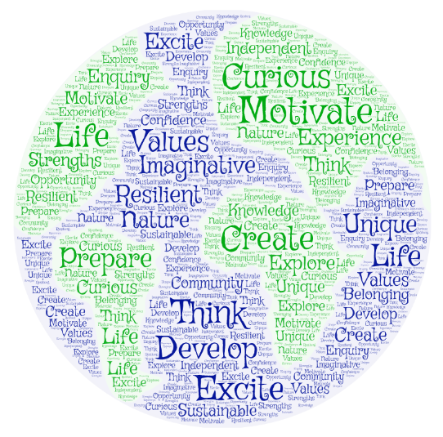

Approved by: | Governors and Staff | Date: June 2022
Last reviewed on: | September 2024
Next review due by: | September 2025

Our PSHE/Citizenship Intent:
We aim to support all pupils in developing their emotional literacy: their understanding of themselves, their relationships, their emotions and their health. We would like each child to become increasingly confident, physically and emotionally aware and responsible.

Outcomes
In PSHE/Citizenship education at Kington Primary School we want our children to be reasonable, effective and independent thinkers who are able to develop their own values within a culture of mutual respect and understanding. We want them to be thoughtful, caring and responsive members of their immediate and wider communities. We want them to be able to make important decisions with regard to their physical and emotional health with the ability to seek help and guidance and to be able to discuss emotions, feelings and thoughts.

Implementation of the PSHE/Citizenship Curriculum:
At Kington Primary, we will implement the PSHE/ Citizenship Curriculum using Jigsaw PSHE, SEAL, Values Based Education, Enrichment and PSHE Association guidance

Cross curricular
Throughout the whole curriculum, opportunities to extend and promote PSHE should be sought. It lends its self well to all aspects of learning but particularly RE

Teaching and Learning
The approach to the teaching of PSHE within the school is based on:-
Circle Time, Jigsaw Sessions, Assemblies and the following examples:
- Buddy Days
- Class routines and rules
- Forest School sessions
- Internet Safety Week
- Remembrance Day
- House Captain elections
- Sport’s Council elections
- Y6 Ambassador roles
- Fire Safety education
- Road Safety education
- Money Mondays
- Bikeablity (Yr6)
- Duties and Monitoring (Yr5/Yr6)
Appendix A should be referred to which lays out the PSHE Association ten guiding principles.

Inclusion and equal opportunities
All children are provided with equal access to the PSHE curriculum. We aim to provide suitable learning opportunities regardless of gender, ethnicity or home background. All children will have their specific needs met through an understanding of their individuality.

Resources
- Jigsaw PSHE scheme – songs, lesson plans, online resources and toys
- SEAL
- Chanel Four SRE
- NSPCC
- Shelter
- Teachitprimary.co.uk seal-pshe
- PSHE Association
- Books will be shared with staff and a resource library kept.

Assessment
The Jigsaw PSHE scheme is weighted towards talk and discussion rather than paper-based work. This was one of the factor that was taken into account when the decision was made to adopt the scheme as pupil-voice discussions had identified that children wanted “more talk, less writing” in PSHE. However, assessment in cross curricular subjects should follow the school policy. Staff who deliver PSHE sessions should engage in continuous, formative assessment of PSHE for their class and should note any individual needs.
Classes may choose to record work in PSHE in a PSHE/Citizenship book or log reflecting the subject throughout the year. This will also reference SMSC. They may also choose to record work in PSHE through photos or videos or the use of the Tapestry online learning journal in the EYFS.
The subject lead will review PSHE/Citizenship through the use of classroom observations, book scrutinies (where PSHE books are used), pupil-voice discussions and also the use of other assessment and monitoring tools during dedicated Curriculum Co-ordinator time.

Marking and presentation
Teachers are expected to adhere to the schools marking policy when marking books and to the presentation policy when guiding children as to how to present their work.

Impact - Monitoring and Evaluating the PSHE/Citizenship Curriculum
The subject coordinator, alongside the senior management team, are responsible for monitoring and evaluating curriculum progress. This is done through book scrutiny, planning scrutiny, lesson observations, pupil interviews, staff discussions and audit of resources.

Review
The PSHE/Citizenship policy will be reflected in our practise. The policy will be reviewed annually.

Appendix A:
PSHE Association ten principles underpin all of our work and guidance for teachers and schools.
The PSHE Association has developed the following evidence-based principles of good practice in PSHE education:
1. Start where children and young people are: find out what they already know, understand, are able to do and are able to say. For maximum impact involve them in the planning of your PSHE education programme.
2. Plan a ‘spiral programme’ which introduces new and more challenging learning, while building on what has gone before, which reflects and meets the personal developmental needs of the children and young people.
3. Take a positive approach which does not attempt to induce shock or guilt but focuses on what children and young people can do to keep themselves and others healthy and safe and to lead happy and fulfilling lives.
4. Offer a wide variety of teaching and learning styles within PSHE education, with an emphasis on interactive learning and the teacher as facilitator.
5. Provide information which is realistic and relevant and which reinforces positive social norms.
6. Encourage young people to reflect on their learning and the progress they have made, and to transfer what they have learned to say and to do from one school subject to another, and from school to their lives in the wider community.
7. Recognise that the PSHE education programme is just one part of what a school can do to help a child to develop the knowledge, skills, attitudes and understanding they need to fulfil their potential. Link the PSHE education programme to other whole school approaches, to pastoral support, and provide a setting where the responsible choice becomes the easy choice. Encourage staff, families and the wider community to get involved.
8. Embed PSHE education within other efforts to ensure children and young people have positive relationships with adults, feel valued and where those who are most vulnerable are identified and supported.
9. Provide opportunities for children and young people to make real decisions about their lives, to take part in activities which simulate adult choices and where they can demonstrate their ability to take responsibility for their decisions.
10. Provide a safe and supportive learning environment where children and young people can develop the confidence to ask questions, challenge the information they are offered, draw on their own experience, express their views and opinions and put what they have learned into practice in their own lives.

