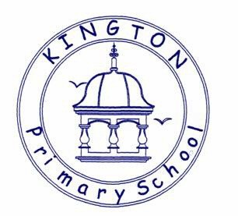

Kington Primary School
RSHE Policy

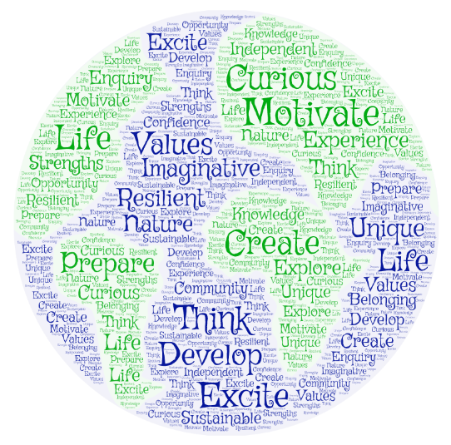

Approved by: | Governors and Staff | Date: September 2022
Last reviewed on: | September 2024
Next review due by: | September 2025

Our INTENT for RSHE at Kington Primary School:
We aim for each child to be able to talk openly and honestly about feelings, emotions and relationships in an ethos of mutual respect and shared values (The equality act 2010 supports the delivery of inclusivity with respect at its core).
Our whole school approach to the teaching of RSHE, using the Jigsaw scheme of work, aims to create a safe and secure environment for pupils to share their thoughts and ideas, raise questions and reflect on their feelings without judgement.
PSHE and RSHE have always been a priority for our children as they live, learn, and grow at Kington. As a Values based school who also follows the Harmony principals, relationships are at the heart of all we do, as is our desire to ensure that children are secure in the knowledge that they should be cared for and valued in all respects. We aim to give them the knowledge and the confidence to be able to share their thoughts, emotions, and worries.
We aim to help pupils learn about themselves and the world they live in, giving them the skills, understanding, and information they need for life. This will help them to stay safe and to flourish, not just in childhood, but into adulthood. We also aim to give pupils the information that they need to make good decisions about their physical and mental health and wellbeing. Pupils will recognise what is normal and what is an issue for themselves and others, and how to seek support at the earliest stage from appropriate sources.
We believe that RSHE is a vital part of equipping our children for life in the 21st century, enabling them to embrace diversity, make the most of technology and develop the skills which will lead to them to being able to sustain healthy and strong relationships.

IMPLEMENTATION of RSHE
By law primary schools are required to teach relationships and health education, alongside national curriculum science and within the context of safeguarding. The Sex Education aspects are non-statutory at the Primary Phase and at this point, following consultation with families, staff, and governors, we will not be teaching this specific area in detail. However, there are elements of this, namely those of relationships and health and physical development, that we do consider necessary, and we will teach these using appropriate vocabulary. By including these elements, we will ensure that we prepare the children for Secondary School.
At key stages 1 and 2, the national curriculum for science includes teaching about the main external parts of the body and the changes to the human body as it grows from birth to old age, including puberty, and sexual and asexual reproduction in mammals and plants. As a local authority school, we teach science in line with the national curriculum. Puberty, including menstruation, will be covered in Health Education and should, as far as possible, be addressed before children begin puberty. We will continue to encourage families to keep us informed with regard to their child’s individual physical development.
The Jigsaw PSHE Scheme that we follow in school is also fully compliant with the DfE Statutory Relationships and Health Education Guidance and RSHE is already embedded in our PSHE (Personal Social Health Education) curriculum. The school Progression Map for PSHE and RSHE clearly identifies where statutory objectives for RSHE are covered in our Jigsaw sessions. The use of appropriate vocabulary and the consideration of all aspects of RSHE will develop throughout school from our Early Years through to Year Six and this vocabulary development is explicit in the Jigsaw scheme.
When delivering RSHE sessions, we will identify the children’s prior knowledge through our understanding of them both as individuals and as a cohort. We will be aware of any community and contextual issues. Discussion and exploration of knowledge and understanding is key. Learning will range from the formal use of resources to a cross curricula approach with opportunities to express and explore through drama, art, music, physical activity or quiet reflective time. There will not always be a visual end result but an emotional growth. Links will be made with other areas of the curriculum and specific events in the life of the school and both nationally and internationally. We will assess the children’s learning and progress through teacher assessment and any evidence of work completed. Much of this will be through discussion and exploration.
All staff should be confident to deliver the core RSHE curriculum and to respond to any question or concerns raised by the children with external support, where necessary, and the use of resources to enhance our own practice and knowledge. Appendix A gives an indication of some of the sources of information/advice and possible resources for use within school.
Throughout the consideration and delivery of RSHE we will promote both male and female staff as adults that all children can communicate with on any aspect but will be sensitive of the need to offer same sex consultation if this is the most sensitive and supportive. Puberty and menstruation are sensitive topics to teach and therefore we will put special measures in place to make sure that pupils feel at ease when talking about these topics. We may have single sex classes for specific sessions so that children feel relaxed and confident in asking questions and sharing thoughts.
Although there continues to be no right for children to withdraw from national curriculum science or Relationships and Health Education (Physical Health and Mental Wellbeing), we are always available to discuss any worries with our families. We know that parents/carers are a child’s first and most effective teacher and will ensure that we share our curriculum with families as well as listening to any concerns or questions raised. It is vital that we educate our children about these important subjects in partnership with parents and carers. In sharing our curriculum with home via our school website class pages and Jigsaw’s Parent-Teacher Knowledge organisers and keeping families informed through class information sessions and Coffee Mornings, we hope to be proactive in our shared approach to RSHE.

IMPACT of RSHE
We will evidence pupils’ learning and progress through discussions at individual, small group, and whole class level and thorough observation of the children in their relationships with each other and confidence in themselves. There may also be written evidence, particularly when aspects of RSHE have been covered in science lessons.
We will ensure that resources and the Jigsaw scheme are being used effectively and that the children’s understanding and development has prepared them for the next stage. Subject Lead observations of RSHE sessions will be undertaken alongside pupil-voice conversations with children.
We will liaise with families, through class pages on the school website, information sent home, class information sessions and Coffee Mornings, and ensure that our curriculum is relevant and supportive of their needs.
We should also see that our practice in safeguarding children is further enhanced by the children’s confidence in and ability to share important aspects of relationships with an appropriate adult.
An annual formal curriculum review will be undertaken by Mrs Palfreman and the Senior Leadership Team.

Appendix A
DfE RSHE Guidance:

https://www.gov.uk/government/publications/relationships-education-relationships-and-sex-education-rse-and-health-education

Jigsaw:

www.jigsawpshe.com/primary-pshe-scheme-of-work-including-statutory-relationships-and-health-education

NSPCC:

https://www.nspcc.org.uk

VbE:

https://valuesbasededucation.com

Harmony in Education:

www.theharmonyproject.org.uk/harmony-education

Big life journal:

https://biglifejournal.com

Birds and Bees:

https://birdsandbeesandkids.com

