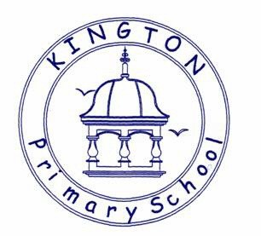

Kington Primary School

Geography Policy

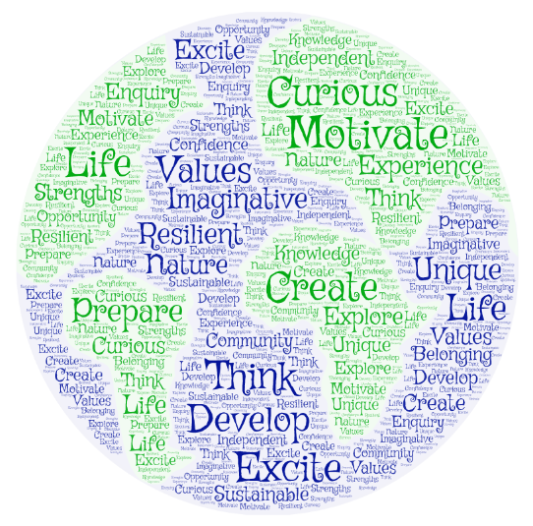

Approved by: | Governors and Staff | Date: April 2025
Last reviewed on: | April 2025
Next review due by: | April 2026

The Importance of Geography
We live in a world of amazing beauty, infinite complexity and rigorous challenge. Geography is the subject which opens the door to this dynamic world and prepares each one of us for the role of global citizen in the 21st century. Through studying geography, people of all ages begin to appreciate how places and landscapes are formed, how people and environments interact, what consequences arise from our everyday decisions, and what a diverse range of cultures and societies exist and interconnect. Geography is a subject which builds on young people’s own experiences, helping them to formulate questions, develop their intellectual skills and find answers to issues affecting their lives. It introduces them to distinctive investigative tools such as maps, fieldwork and the use of powerful digital communication technologies. It opens their eyes to the beauty and wonder around them and acts as a source of inspiration and creativity. More than this, it ensures that they appreciate the complexity of attitudes and values which shape the way we use and misuse the environment. Through geography, people learn to value and care for the planet and all its inhabitants.

Our Geography Intent:
We aim to develop lively, enquiring minds encouraging pupils to become self-motivated, confident and curious about the world around them.
The National Curriculum for geography aims to ensure that all pupils:
- develop contextual knowledge of the location of globally significant places – both terrestrial and marine – including their defining physical and human characteristics and how these provide a geographical context for understanding the actions of processes.

- understand the processes that give rise to key physical and human geographical features of the world, how these are interdependent and how they bring about spatial variation and change over time.

- are competent in the geographical skills needed to:
a) collect, analyse and communicate with a range of data gathered through experiences of fieldwork that deepen their understanding of geographical processes
b) interpret a range of sources of geographical information, including maps, diagrams, globes, aerial photographs and Geographical Information Systems (GIS)
c) communicate geographical information in a variety of ways, including through maps, numerical and quantitative skills and writing at length.

Outcomes
In Geography education at Kington Primary School we aim:
• to enable children to gain knowledge and understanding of places in the world;
• to increase children’s knowledge of other cultures and, in so doing, teach a respect and understanding of what it means to be a positive citizen in a multi-cultural country;
• to allow children to learn graphic skills, including how to use, draw and interpret maps;
• to enable children to know and understand environmental problems at a local, regional and global level;
• to encourage in children a commitment to sustainable development and an appreciation of what ‘global citizenship’ means;
• to develop a variety of other skills, including those of enquiry, problem solving, ICT, investigation and how to present their conclusions in the most appropriate way.

Implementation of the Geography Curriculum
We carry out curriculum planning in geography in three phases (long-term, medium-term and short-term). Our geography curriculum is delivered using the new Early Years Learning goals and the 2014 National Curriculum Programmes of Study for Geography as a tool to ensure appropriate pace, progression and coverage of the subject. This coverage is reviewed continually by class teachers and planning is adjusted accordingly to ensure appropriate coverage of all mathematical strands.
Foundation Stage
The programme of study for the Foundation stage is set out in the statutory framework for the Early Years Foundation Stage 2023. We teach geography in the EYFS as an integral part of the topic work covered during the year. Our Early Years ‘Intent, Implementation and Impact’ policy details goals in the ‘Understanding of the World’ section.
Key Stage 1 and 2
The Programmes of study for geography are set out year by year for Key Stages 1 and 2 in the new National Curriculum (2014) as follows:
Key Stage 1
During Key Stage 1, pupils investigate their local area and a contrasting area in the United Kingdom or abroad, finding out about the environment in both areas and the people who live there. They also begin to learn about the wider world. They carry out geographical enquiry inside and outside the classroom. In doing this, they ask geographical questions about people, places and environments, and use geographical skills and resources, such as maps and photographs.
By the end of Year 2, pupils should know more about our local area of Kington, using maps and directions alongside mapping, photographs and fieldwork. In addition, children can discuss similarities and differences to other places, including contrasting areas such as Australia.
Key Stage 2
During Key Stage 2, pupils investigate a variety of people, places and environments in the United Kingdom and abroad, and start to make links between different places in the world. They find out how people affect the environment and how they are affected by it. Pupils carry out geographical enquiry inside and outside the classroom. In doing this, they ask geographical questions, and use geographical skills and resources, such as maps, atlases, aerial photographs and ICT. Children will develop geographical enquiry skills, including asking geographical questions, collecting and recording information and identifying different views. They will acquire the appropriate practical skills associated with Geography, including using suitable vocabulary, fieldwork techniques and maps, plans and atlases. Pupils will use secondary sources of information with accuracy, including aerial photographs, satellite images, etc. As well as making its own distinctive contribution to the school curriculum, geography contributes to the wider aims of primary education. Teachers will ensure that links between subjects are maximized.
By the end of Year 4, pupils should … be more confident in comparing locations; mapping the physical and human features and describing other key information. Linking with history work, children should have studied Egypt or Rome, using other locational vocabulary such as equator, hemisphere, longitude and latitude. Children can use fieldwork skills to study local areas and rivers, using mapping, an eight-point compass and sketching.
By the end of Year 6, pupils should be fluent in mapping and looking at local maps/photos. Children can use OS maps and an eight-point compass. Children have a further knowledge of UK locational knowledge and how land use has changed over time. An in depth into rivers and mountains link to history topics too.

Cross curricular
Throughout the whole curriculum, opportunities to extend and promote Geography should be sought.
English - Geography makes a significant contribution to the teaching of English in our school because it actively promotes the skills of reading, writing, speaking and listening. At Key Stage 2 we organise debates on environmental issues because we believe that these develop speaking and listening skills. Reports, letters and recording information will all develop children’s writing ability. We also use environmental issues as a way of developing the children’s writing ability by asking them to record information and write reports and letters.
Mathematics - Geography in our school contributes to the teaching of mathematics in a variety of ways. We teach the children to represent objects with maps. The children study space, scale and distance and they learn how to use four and six figure grid references and eight point compasses. They also use graphs to explore, analyse and illustrate a variety of data.
Computing - We make provision for the children to use the computer in geography lessons where appropriate. We incorporate ICT in our geography curriculum planning in EYFS, KS1 and KS2. Children use ICT in geography to enhance their skills in data handling and in presenting written work. They research information through the internet (safe search is used). We also offer children the opportunity to use the digital camera to record and use photographic images. Bee-Bots (small programmable robots) are used for direction and mapping work. Google Earth is a valuable mapping tool.
Personal, Social and Health Education (PHSE) and Citizenship - Geography can inspire pupils to develop their concept of themselves as a global citizen and become aware of a range of social issues which would be beyond their own experience. The children organise campaigns on matters of concern to them, such as responding to famine, natural disasters and refugees. For example, children study the way people recycle materials and how environments are changed for better or for worse and the impact an individual may make. The nature of the subject means that children have the opportunity to take part in debates and discussions. Thus geography in our school promotes the concept of positive citizenship. Spiritual, Moral, Social and Cultural Development We offer children in our school many opportunities to examine the fundamental questions in life through the medium of geography. For example, their work on the changing landscape and environmental issues leads children to ask questions about the evolution of the planet. We encourage the children to reflect on the impact of mankind on our world and we introduce the concept of ‘stewardship’ in relation to sustainable development. Through teaching about contrasting localities we enable the children to learn about inequality and injustice in the world.
We help children to develop their knowledge and understanding of different cultures so that they learn to avoid stereotyping other people and acquire a positive attitude towards others. We help contribute to the children’s social development by teaching them about how society works to resolve difficult issues of economic development. Geography contributes to the children’s appreciation of what is right and wrong by raising many moral questions during the programme of study
Teaching and Learning
We use a variety of teaching and learning styles in our geography lessons. We believe in whole-class teaching methods and we combine these with enquiry based research activities. We encourage children to ask as well as answer geographical questions. We offer them the opportunity to use a variety of data such as maps, statistics, graphs, pictures and aerial photographs and we enable them to use computing in geography lessons where this serves to enhance their learning. Children take part in role-play and discussions and they present reports to the rest of the class
The curriculum is delivered by class teachers. All work is differentiated in order to give appropriate levels of work and children are taught in ability groups from the end of Year 2. There is one form entry with each class teacher taking responsibility for their year. Planning is based upon the new National Curriculum (2014). Programmes of Study should inform medium term plans and subsequently weekly planning. Class teachers are responsible for the relevant provision of their own classes and individually develop weekly plans which give details of learning objectives and appropriate differentiated activities. Although planned in advance, they are adjusted on a daily basis to better suit the arising needs of a class and individual pupils.
Inclusion and equal opportunities
All children are provided with equal access to the geography curriculum. We aim to provide suitable learning opportunities regardless of gender, ethnicity or home background. All children will have their specific needs met through differentiated work in conjunction with targets. Additional support is planned for and provided in relation to identified needs for individuals and groups.
Resources
Resources which are not used or required regularly are stored centrally and accessed by teachers at the beginning of a topic. We also use a range of web-based resources to help with consolidation and support in school. Resources are audited annually.
Assessment
Children in the Foundation Stage are assessed in accordance with the EYFS curriculum.
We assess children’s work in geography by making informal judgements as we observe the children during lessons. Once the children complete a piece of work we mark and comment as necessary. This information then informs planning. The progress of an individual pupil in this area of the curriculum is reported at the end of the academic year.
Marking and presentation
Teachers are expected to adhere to the schools marking policy when marking books and presentation policy when guiding children as to how to present their work.

Impact - Monitoring and Evaluating the Geography Curriculum
The subject coordinator, alongside the senior management team, are responsible for monitoring and evaluating curriculum progress. This is done through book scrutiny, planning scrutiny, lesson observations, pupil interviews, staff discussions and audit of resources.
Review
The geography policy will be reflected in our practise. The policy will be reviewed annually.

