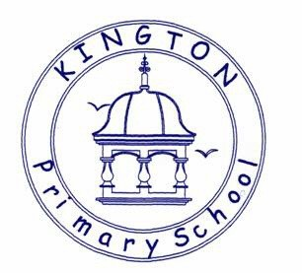

Kington Primary School

History Policy

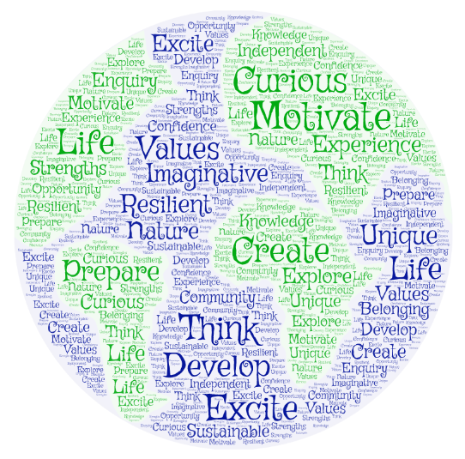

Approved by: | Governors and Staff | Date: April 2025
Last reviewed on: | April 2025
Next review due by: | April 2026

The Importance of History

Our History Intent:
At Kington Primary School we believe that History encourages pupils to consider how the past has influenced the present, and how a variety of elements influenced people’s actions. History also develops the skills of researching and considering evidence, the knowledge of past events, civilisations and personalities and the concepts of chronology. Learning about the past can influence pupils’ attitudes to the present and the future.

The National Curriculum for history aims to ensure that all pupils:
- know and understand the history of these islands as a coherent, chronological narrative, from the earliest times to the present day: how people’s lives have shaped this nation and how Britain has influenced and been influenced by the wider world
- know and understand significant aspects of the history of the wider world: the nature of ancient civilisations; the expansion and dissolution of empires; characteristic features of past non-European societies; achievements and follies of mankind
- gain and deploy a historically grounded understanding of abstract terms such as ‘empire’, ‘civilisation’, ‘parliament’ and ‘peasantry’
- understand historical concepts such as continuity and change, cause and consequence, similarity, difference and significance, and use them to make connections, draw contrasts, analyse trends, frame historically-valid questions and create their own structured accounts, including written narratives and analyses
- understand the methods of historical enquiry, including how evidence is used rigorously to make historical claims, and discern how and why contrasting arguments and interpretations of the past have been constructed
- gain historical perspective by placing their growing knowledge into different contexts, understanding the connections between local, regional, national and international history; between cultural, economic, military, political, religious and social history; and between short- and long-term timescales.
Outcomes
In History education at Kington Primary School, we aim to deliver a curriculum which is accessible to all and that will maximise the outcomes for every child so that they know more, remember more and understand more. The aims of history in our school are:
- to foster in children an interest in the past and to develop an understanding that enables them to enjoy all that history has to offer;
- to enable children to know about significant events in British history and to appreciate how things have changed over time;
- to develop a sense of chronology;
- to know and understand how the British system of democratic government has developed and, in so doing, to contribute to a child’s citizenship education;
- to understand how Britain is part of a wider European culture and to study some aspects of European history;
- to have some knowledge and understanding of historical development in the wider world;
- to help children understand society and their place within it, so that they develop a sense of their cultural heritage;
- to develop in children the skills of enquiry, investigation, analysis, evaluation and presentation

Implementation of the History Curriculum
We carry out curriculum planning in history in three phases (long-term, medium-term and short-term as part of teachers’ weekly planning). Our history curriculum is delivered using the programme of study set out in the Early Years Foundation Stage 2023 and the 2014 National Curriculum Programmes of Study for History as a tool to ensure appropriate pace, progression and coverage of the subject. Class teachers review this coverage continually and planning is adjusted accordingly to ensure appropriate coverage of all history strands.
Foundation Stage
The programme of study for the Foundation stage is set out in the Early Years Foundation Stage 2023. This provides children with the skills to:
• Talk about the lives of the people around them and their roles in society.
• Know some similarities and differences between things in the past and now, drawing on their experiences and what has been read in class.
• Understand the past through settings, characters and events encountered in books read in class and storytelling.
• Know some similarities and differences between different religious and cultural communities in this country, drawing on their experiences and what has been read.
Key Stage 1 and 2
The Programmes of study for history are set out year by year for Key Stages 1 and 2 in the National Curriculum (2014).
Key Stage 1
The principal focus of History teaching in Key Stage 1 is to ensure that pupils develop an awareness of the past, using common words and phrases relating to the passing of time. They should know where the people and events they study fit within a chronological framework and identify similarities and differences between ways of life in different periods. They should use a wide vocabulary of everyday historical terms. They should ask and answer questions, choosing and using parts of stories and other sources to show that they know and understand key features of events. They should understand some of the ways in which we find out about the past and identify different ways in which it is represented.
By the end of Year 2, pupils should know about:
- changes within living memory. Where appropriate, these should be used to reveal aspects of change in national life
- events beyond living memory that are significant nationally or globally the lives of significant individuals in the past who have contributed to national and international achievements. Some should be used to compare aspects of life in different
- significant historical events, people and places in their own locality.

Key Stage 2
The principal focus of history teaching in Key Stage 2 is to ensure that pupils continue to develop a chronologically secure knowledge and understanding of British, local and world history, establishing clear narratives within and across the periods they study. They should note connections, contrasts and trends over time and develop the appropriate use of historical terms. They should regularly address and sometimes devise historically valid questions about change, cause, similarity and difference, and significance. They should construct informed responses that involve thoughtful selection and organisation of relevant historical information. They should understand how our knowledge of the past is constructed from a range of sources.

By the end of Year 6 pupils should know about:
- changes in Britain from the Stone Age to the Iron Age
- the Roman Empire and its impact on Britain
- Britain’s settlement by Anglo-Saxons and Scots
- the Viking and Anglo-Saxon struggle for the Kingdom of England to the time of Edward the Confessor
- a local history study
- a study of an aspect or theme in British history that extends pupils’ chronological knowledge beyond 1066
- the achievements of the earliest civilizations – an overview of where and when the first civilizations appeared and a depth study of one of the following: Ancient Sumer; The Indus Valley; Ancient Egypt; The Shang Dynasty of Ancient China
- Ancient Greece – a study of Greek life and achievements and their influence on the western world
- a non-European society that provides contrasts with British history – one study chosen from: early Islamic civilization, including a study of Baghdad c. AD 900; Mayan civilization c. AD 900; Benin (West Africa) c. AD 900-1300.

Cross-curricular
Throughout the whole curriculum, opportunities to extend and promote History should be sought. Any cross curriculum links between subjects are identified in long and medium term planning, and children are made aware of them.

English
History contributes significantly to the teaching of English in our school by actively promoting the skills of reading, writing, speaking and listening. Some of the texts that we use in literacy are historical in nature. Children develop oracy through discussing historical questions or presenting their findings to the rest of the class and presenting their work in class assemblies. They develop their writing ability by composing reports and letters and through using writing frames.
Mathematics
History teaching contributes to the teaching of mathematics in a variety of ways. Children learn to use numbers when developing a sense of chronology through doing activities such as time-lines. Children learn to interpret information presented in graphical or diagrammatic form.
Computing
We use computing in history teaching where appropriate and we meet the statutory requirement for children to use ICT as part of their work in history at Key Stage 2. Children use ICT in history to enhance their skills in data handling and in presenting written work, and they research information using the Internet. Children have the opportunity to use the digital camera to record and use photographic images.
Personal, social and health education (PSHE) and citizenship
History contributes significantly to the teaching of personal, social, citizenship and health education. Children develop self-confidence by having opportunities to explain their views on a number of social questions. They discover how to be active citizens in a democratic society by learning how laws are made and changed, and they learn how to recognize and challenge stereotypes and to appreciate that racism is a harmful aspect of society. They learn how society is made up of people from different cultures and start to develop tolerance and respect for others.
Spiritual, moral, social and cultural development
When teaching history, we contribute to the children’s spiritual development where possible. Children learn about democracy in Ancient Greece and they find out how British society has changed over time. The history programme of study enables children to understand that Britain’s rich cultural heritage can be further enriched by the multi-cultural British society of today.

Teaching and Learning
History is taught through discrete lessons and through topic work throughout Key Stage 1 and 2. Please refer to our Long Term Plan for History. In the Foundation Stage History is taught through termly theme based work with learning objectives distributed over a two year cycle. Early historical skills and concepts are delivered throughout the year.
Planning is based upon the National Curriculum (2014). Programmes of Study should inform medium term plans and subsequently weekly planning. Class teachers are responsible for the relevant provision of their own classes and individually develop weekly plans which give details of learning objectives and appropriate differentiated activities. Although planned in advance, they are adjusted on a daily basis to better suit the arising needs of a class and individual pupils.
Teaching Methods
We use a variety of teaching methods at Kington Primary School, in order to suit as much as possible the abilities and interests of our pupils. These include:
- Use of story, including story telling
- Discussions and debate
- Questions and answers
- Individual and group investigations
- Television, radio, audio recording, video, film, internet and other computing resources
- Role play and drama
- Visits to museums and historic sites
Each history topic will usually include:
- Place the history being studied in the chronological context of previous learning, using a timeline.
- Reviewing previous learning.
- Learning key vocabulary
- Conducting a historical enquiry using a variety of sources and/or artefacts
- Interpreting findings.
- Communicating their historical knowledge and understanding.
- Evaluating their learning.

Inclusion and equal opportunities
All children are provided with equal access to the history curriculum. We aim to provide suitable learning opportunities regardless of gender, ethnicity or home background. All children will have their specific needs met through differentiated work in conjunction with targets. Within the curriculum area of History SEND children will be provided. Advice can be sought from the school's SENDCO where applicable.

Resources
Resources which are not used or required regularly are stored centrally and accessed by teachers at the beginning of a topic. We also use a range of web-based resources to help with consolidation and support in school.
Assessment
Children in the Foundation Stage are assessed in accordance with the EYFS curriculum.
At Kington Primary assessment in history comprises of teacher assessment during the delivery of lessons. Children are given tasks linked to the NC, and assessed against these. It is the responsibility of each individual class teacher to implement this through planning activities linked to the History National Curriculum. At the end of a unit of work teachers use agreed ARE to access children.
Marking and presentation
Teachers are expected to adhere to the schools marking policy when marking books and presentation policy when guiding children as to how to present their work.

Impact - Monitoring and Evaluating the History Curriculum
The subject coordinator, alongside the senior management team, are responsible for monitoring and evaluating curriculum progress. This is done through book scrutiny, planning scrutiny, lesson observations, pupil interviews, staff discussions and audit of resources.
Review
The History policy will be reflected in our practise. The policy will be reviewed annually.

