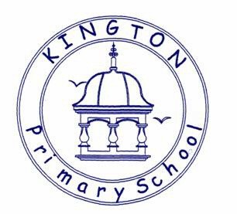

Kington Primary School

Science Policy

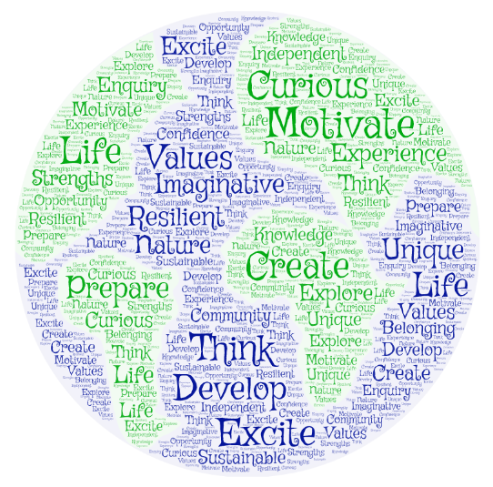

Approved by: | Governors and Staff | Date: May 2025
Last reviewed on: | May 2025
Next review due by: | May 26

The Importance of Science

Our Science Intent:

Science in our school is about developing children’s ideas and ways of working that enable them to make sense of the world in which they live through investigation, as well as using and applying processing skills. We want to provide our children with rich learning experiences that aim to:

- Prepare our children for life in an increasingly scientific and technological world today and in the future.
- Help our children acquire a growing understanding of the nature, processes and methods of scientific ideas.
- Help develop and extend our children’s scientific concept of their world.
- Build on our children’s natural curiosity and developing a scientific approach to problems.
- Encouraging open-mindedness, self-assessment, perseverance and developing the skills of investigation – including: observing, measuring, predicting, hypothesising, experimenting, communicating, interpreting, explaining and evaluating.
- Develop the use of scientific language, recording and techniques.
- Develop the use of computing in investigating and recording.
- Make links between science and other subjects.
- Provide all children with a broad and balanced science curriculum.

The National Curriculum for science aims to ensure that all pupils:
- have high-quality science education that provides the foundations for understanding the world through the specific disciplines of biology, chemistry and physics.
- are taught essential aspects of the knowledge, methods, processes and uses of science.
- are encouraged to recognise the power of rational explanation and develop a sense of excitement and curiosity about natural phenomena.
- are encouraged to understand how science can be used to explain what is occurring, predict how things will behave, and analyse causes.
Outcomes
In Science education at Kington Primary School we aim to ….
- develop scientific knowledge and conceptual understanding through the specific disciplines of biology, chemistry and physics
- develop understanding of the nature, processes and methods of science through different types of science enquiries that help them to answer scientific questions about the world around them
- are equipped with the scientific knowledge required to understand the uses and implications of science, today and for the future

Implementation of the Science Curriculum
We carry out curriculum planning in science in three phases (long-term, medium-term and short-term). Our science curriculum is delivered using the new Early Years framework (Understanding of the world element) and the 2014 National Curriculum Programmes of Study for Science as a tool to ensure appropriate pace, progression and coverage of the subject. This coverage is reviewed continually by class teachers and planning is adjusted accordingly to ensure appropriate coverage of all science strands.
Foundation Stage
Early Years uses the non-statutory Development Matters guidance to plan. This provides children with the skills to begin to understand the world and guides the children to make sense of their physical world and their community through opportunities to explore, observe and find out about people, places, technology and the environment
Key Stage 1 and 2
The Programmes of study for science are set out year by year for Key Stages 1 and 2 in the new National Curriculum (2014)
Key Stage 1
The principal focus of science teaching in Key Stage 1 is to ensure that pupils:
- experience and observe phenomena, looking more closely at the natural and humanly-constructed world around them.
- are encouraged to be curious and ask questions about what they notice.
- develop their understanding of scientific ideas by using different types of scientific enquiry to answer their own questions, including observing changes over a period of time, noticing patterns, grouping and classifying things, carrying out simple comparative tests, and finding things out using secondary sources of information.
- begin to use simple scientific language to talk about what they have found out and communicate their ideas to a range of audiences in a variety of ways.
- learn about science through the use of first-hand practical experience and some appropriate secondary sources, such as books, photographs and videos.
- are taught ‘Working scientifically’ through clearly related science content in the programme of study
- read and spell scientific vocabulary at a level consistent with their increasing word reading and spelling knowledge at key stage 1.

By the end of Year 2, most pupils should meet the expected standard.
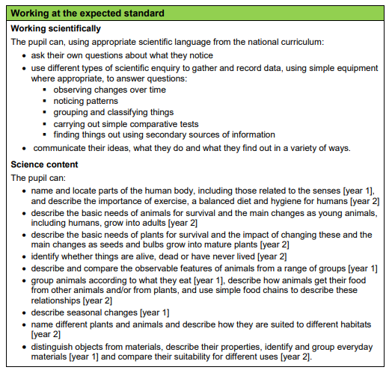

Key Stage 2
The principal focus of science teaching in Key Stage 2 is to ensure that pupils:
- broaden their scientific view of the world around them, through exploring, talking about, testing and developing ideas about everyday phenomena and the relationships between living things and familiar environments, and by beginning to develop their ideas about functions, relationships and interactions.
- should ask their own questions about what they observe and make some decisions about which types of scientific enquiry are likely to be the best ways of answering them, including observing changes over time, noticing patterns, grouping and classifying things, carrying out simple comparative and fair tests and finding things out using secondary sources of information.
- should draw simple conclusions and use some scientific language, first, to talk about and, later, to write about what they have found out.
- ‘Work scientifically’. Scientific enquiry should include: observing over time; pattern seeking; identifying, classifying and grouping; comparative and fair testing (controlled investigations); and researching using secondary sources. Pupils should seek answers to questions through collecting, analysing and presenting data.
- read and spell scientific vocabulary correctly and with confidence, using their growing word reading and spelling knowledge.

The By the end of Year 6, most pupils should meet the expected standard in science.
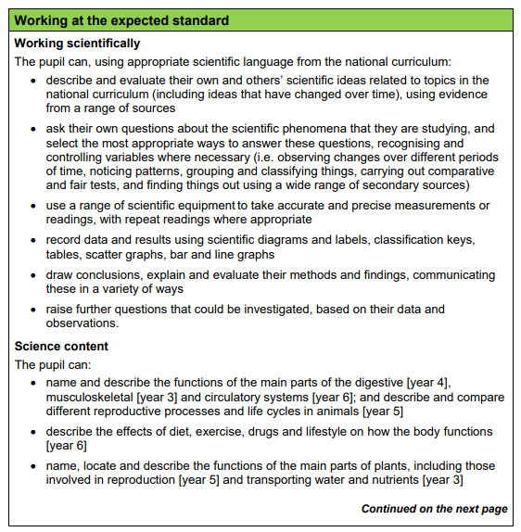

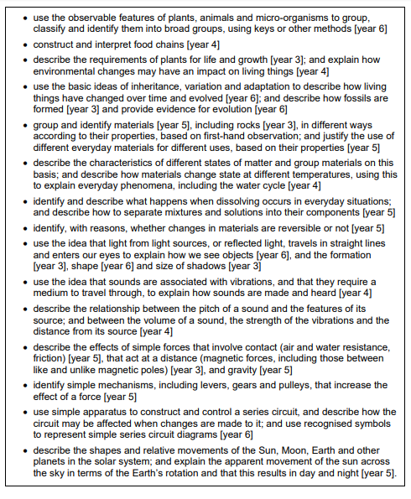

Cross curricular
Throughout the whole curriculum, opportunities to extend and promote Science should be sought.
Mathematics
This is the subject, which most obviously links with Science. Science offers opportunities for practical application of many mathematical skills from basic computation to the drawing and interpretation of graphs, tables and pie-charts. Through working on investigations children learn to estimate, predict, accurately observe and record events. Science also provides opportunities for practical measurement and comparisons of: time, weight, length, capacity, area, volume and the weather
English
The whole range of English skills can be developed through Science in a variety of ways.
Speaking and Listening – Science lends itself to class and group discussions, debate, verbal descriptions and the reporting back of findings from investigations. Scientific vocabulary is developed, broadening children’s language.
Reading – Children must read the instructions from sheets or work-cards in order to carry them out. Research from written sources or ICT based sources is also a key skill. Linking the class reading book to a Science topic is also possible
Writing - Science can provide many opportunities for the development of non-fiction writing, reporting, recording, instructing and describing. It can also provide an exciting source for creative writing and poetry.
Computing
Staff and children use ICT in Science lessons where appropriate. They use it to support their work in Science by learning how to find, select and analyse information on the Internet. Children may use ICT to record, present and interpret data and to review, modify and evaluate their work and improve its presentation.
Geography and History
In examining how scientific ideas affect the world we live in, links with geographical and historical aspects of our environment are inevitable. These links tend to be more obvious in the natural Science context; however, study of the environment also lends itself to work in forces and structures, the nature of materials, energy transfer and other aspects of physical Science.
Personal, Social and Health Education (PSHE) and Citizenship
Science makes a significant contribution to the teaching of PSHE. Firstly, the subject matter, primarily ourselves and growth enhances children’s awareness of how bodies change and how to maintain our bodies in a fit and healthy state. P.E can also be linked in closely with science. Matters of citizenship and social welfare are raised when children study recycling and how environments are changed for better or worse. Opportunities to take part in debate and discussions are also available.
Spiritual, moral and cultural development
Science teaching offers children many opportunities to examine some of the fundamental questions in life, for example, the evolution of living things and how the world was created. Science also raises many moral and social questions, e.g. pollution. Children are given the chance to reflect on the way people care for the planet and how science can contribute to the way we manage the Earth’s resources. Science teaches children about the reasons why people are different, by developing the children’s knowledge and understanding of physical

Teaching and Learning
Science is taught as discrete units and lessons. Where possible, Science is linked to class topics. Due to one form year groups in our school, Science units are taught on a year rolling programme. This ensures progression between year groups and guarantees topics are covered. Planning is based upon the new National Curriculum (2014). Programmes of Study inform medium term plans and subsequently weekly planning. We use ‘Kent Scheme of Work ‘as a starting point for our planning. The PLAN matrices https://www.ase.org.uk/resources/plan-matrices can also be used to support planning in depth coverage of each objective, identifying key vocabulary for each topic and suggestions for further learning applications suitable for discovery learning.

Health and Safety:
Where appropriate reminders are given to children about potential hazards and care of the equipment they are using.
Staff plan for H&S in each lesson.

Inclusion and equal opportunities
All children are provided with equal access to the science curriculum. We aim to provide suitable learning opportunities regardless of gender, ethnicity or home background. All children will have their specific needs met in a variety of appropriate and effective ways We aim to remove barriers to learning through adaptive teaching. Teachers refer to ‘Quality First Teaching’ document.
Resources
The Science curriculum folder in ‘Common Staff’ and on OneDrive holds many resources which help teachers with planning and assessment.
Resources are stored centrally in two cupboards in the studio.
Assessment

Children in the Foundation Stage are assessed in accordance with the EYFS curriculum.

Assessment for learning is continuous throughout the planning, teaching and learning cycle.

A variety of assessment methods are used, these include:
• Observing children at work (individually, in pairs, in a group and in classes)
• Questioning, talking and listening to children
• Monitoring of pupils’ work through book looks.

At the end of a unit of work teachers can use ‘Primary Stem’ assessments if they wish. These can be found in the Common staff- Science – Assessment.
In addition to this, the following link, https://www.ase.org.uk/plan, can be used to support teacher assessment of pupils’ learning with exemplifications of every topic in each year group. Teachers can use this to support moderation. KS2 SATs data is reported to parents and the Local Authority.

Marking and presentation
Teachers are expected to adhere to the schools marking policy when marking books and presentation policy when guiding children as to how to present their work.

Impact - Monitoring and Evaluating the Mathematical Curriculum
The subject coordinator, alongside the senior management team, are responsible for monitoring and evaluating progress in science. This is done through book scrutiny, planning scrutiny, lesson observations, pupil interviews, staff discussions and audit of resources.
Review
The science policy will be reflected in our practise. The policy will be reviewed annually.

Reviewed: May 2025
Next review date: January 2026

