Spring Term – Class 3T
Dear Parents and Guardians,
Welcome back and hello 2026! We hope you're all looking forward to the start of a brand-new year and all of the exciting topics we’ll be exploring together. Below is a brief outline of the work planned for this term. As always, if there are any subjects you have a particular interest in or if you have any resources that could enrich our learning, we would greatly appreciate your support.
Thank you,
Miss Tindale
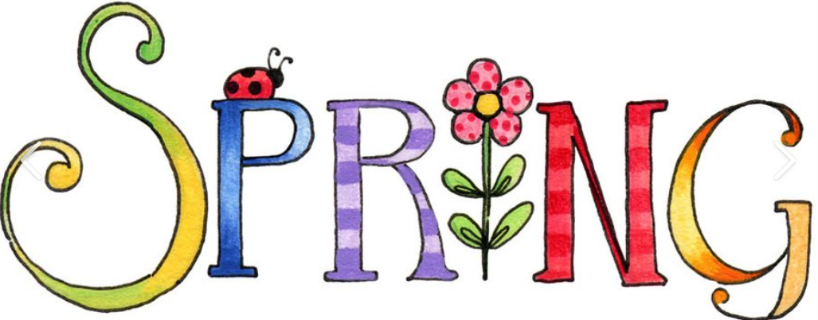
Subject | Detailed Information about our learning | How can you help at home?
English | Reading – we will continue to work on our comprehension skills with a particular focus on answering questions about characters, settings and the main events. We will continue to work every morning from 9 o’clock in an appropriate phonics group which will support accurate reading and spelling.  Writing –  In English, children will develop their reading and writing skills through a range of engaging texts and writing opportunities. They begin by summarising and sequencing the story The Man on the Moon, developing their understanding of characters, events and structure. Children then move on to writing diary entries, inspired by The Man on the Moon and the historical figure Howard Carter, writing in role and considering thoughts, feelings and viewpoints. We will focus on:  - Using ambitious vocabulary  - Writing in the past and present tense correctly  - Using time conjunctions and adverbs  - Organising ideas into paragraphs  - Using fronted adverbials  Children plan and write their own narrative pieces, applying these skills independently. The unit finishes with a creative focus on poetry, where children explore and write a ‘Mummy!’ poem linked to Ancient Egypt, making links across the curriculum.  Handwriting –  We will be working very hard to secure letter formation. Children should be writing as neatly and clearly as they can in all of their writing. We have started a new handwriting scheme and are very much looking forward to seeing the results.  Spelling, Punctuation and Grammar –  In addition to our daily phonics sessions, the children will have a weekly SPaG lesson.  As a class we will be working on specific spellings throughout the year, which will need to be practiced at home and tested each Friday. | Please consider the following ideas:  • Discuss the focus texts  that are being worked on  and talk about the main  features.  • Join Kington library and visit regularly.  • Encourage your child to  read as much  as possible.  • Ask questions about their books (meanings of words etc.). Some example  questions are included at  the end of the pack.  • Encourage your child to use a dictionary and/or  thesaurus to correct any  spellings that need to be  checked in their writing.
Maths | In our maths sessions, we will be focusing on number and calculation, building confidence, accuracy and fluency. Children will explore right angles, learning how to recognise them in shapes and in everyday objects. They will develop their understanding of the additive relationship by manipulating numbers in different ways and securing efficient mental calculation strategies, including partitioning and adjusting.  Children will also learn and practise formal written methods for calculation. This includes column addition, where they will add numbers with increasing confidence and accuracy, and column subtraction, focusing on exchanging where needed. Throughout the unit, children will be encouraged to explain their thinking, check their answers, and apply their skills to problem-solving and reasoning activities.  In addition, we will also be working on our times tables. In Year 3 the focus is the 3-, 4- and 8-times tables as well as revisiting the 2-, 5- and 10-times table. | Please consider the following ideas:  • Support your child with  their times tables whether that be on ‘Times Tables Rockstars’ or in practical ways at home.  • Be aware and identify  everyday uses of maths  (e.g. money, weighing, time  etc.)  • Helping practise number  bonds & facts.  • Practise telling the time.  • Encourage and support your child with homework tasks.
RE | As part of the Herefordshire syllabus, we will be finding out this term about the Muslim and Jewish faith. We will identify some beliefs about God in Islam and make links between beliefs about God and ibadah (worship) and how this links to prayer, fasting, celebrating and the intention to live out the five pillars of Islam.  We will also look at Jewish worldviews and explore Shabbat, Rosh Hashanah, Yom Kippur, and Pesach to build understanding of festivals and ideas of forgiveness, remembering, and freedom. | Discuss with your child what they have learnt each week and how they feel about it.  Discuss moments in their own lives which have been special to them and think why.
Music | This term begins with activities designed to help children identify and describe the ingredients (dimensions) that make up music. The children will explore instruments, learning about instrumental timbres associated with different countries and use this knowledge to create simple accompaniments. As the term moves on, the children will learn how to vary the dimensions of music to evoke mood and atmosphere. They will create suitable music to accompany song lyrics and poetry. The term ends with an opportunity to compose music inspired by stories and settings. The children will create and organize layers of musical sound to create interesting textures and have fun representing these sounds. | Talk to your child about what they have learnt each week in their music lessons.
PE | We are lucky to have Mr Fotheringham from Luctonians Community Coaching joining us on Wednesdays in the first half term to teach us gymnastics.  On a Tuesday, we will be joined by a local cricket coach who will be helping us to develop our skills in cricket. | Please wear correct PE kit to school on a Tuesday and a Wednesday.
Computing | In the first half term we will be exploring the concept of sequencing in programming through Scratch. Children will be introduced to a selection of motion, sound, and event blocks which they will use to create their own programs, featuring sequences. The final project is to make a representation of a piano.  In the second half term children will develop their understanding of what a branching database is and how to create one. They will use yes/no questions to gain an understanding of what attributes are and how to use them to sort groups of objects. Learners will create physical and on-screen branching databases. | If your child has access to a computer, please encourage them to demonstrate the safety rules which we have been discussing in school.
French | After a fantastic first term of learning French, we will be moving on to learning the names of instruments. After half term, we will further deepen our conversational French by learning how to say, “I am able to…” and “I know how too…”. | Please encourage your child to teach you the phrases and vocabulary which we explore each week.
Jigsaw/ PSHE | We will be working through our weekly sessions on the unit ‘dreams and goal’. We will explore ideas linked to challenges, dreams and personal goals for our learning. After half term, we will be looking at making healthy choices, being a good friend and dealing with difficult situations. | Please discuss with your child the main ideas which have been explored in our weekly sessions. What do they think were the main ideas?
Science | In our plant’s unit, children will learn about how plants work and what they need to grow and stay healthy. They explore the different parts of a plant (roots, stem, leaves and flowers), what each part does and how water is transported through the plant. They will also be learning about the basic requirements plants need for life and growth, such as water, light and nutrients. | Find some of your own information about plants which you are particularly interested in.  Discuss what you think we could do to help species of animals which are endangered.
History | In the first half of the term, children learn about Ancient Egypt. They explore who the Ancient Egyptians were and what daily life was like, including homes, jobs and beliefs. They learn about mummification, why it was important, and study the life and discovery of Tutankhamun. Children also look at Egyptian gods and beliefs and finish the unit by learning to write like an Egyptian, exploring hieroglyphs and ancient forms of communication. | Using suggested websites to help you to understand more about these topics.  Discussing at home the main focus of our learning in school.
Geography | In the second half of the term, children focus on the geography of Egypt. They learn to locate Egypt on a map and investigate its key geographical features. This includes studying the River Nile and understanding why it was so important to life in Ancient Egypt. Children also explore Egypt’s tourism industry and why people visit today, as well as learning about desertification and environmental challenges in the region. | Using suggested websites to help you to understand more about these topics.  Discussing at home the main focus of our learning in school.
DT | In our Bread unit, children will have the to taste and describe a variety of different breads from around the world. We will learn about how bread can be part of a balanced diet and the different food groups. Then it is time for children to follow a basic bread recipe to make bread. They will explore adapting the recipe according to given instructions or their own ideas.  As part of our Ancient Egypt topic, children will take part in a Design and Technology project where they learn how papyrus paper was made in Ancient Egyptian times. They will explore the materials and methods used by the Ancient Egyptians, then design and create their own papyrus-style paper. | Having chance at home to try out some of the recipes which we explore in school.
Art | In our art lessons, we will be working with shape and colour. We will choose a piece of art and dive into the specifics of the piece and then create our own collage by ‘painting with scissors’. | Discuss the work which the children have looked at each week and what they enjoyed about it.
Our class readers this term will be ‘The Journey’ by Francesca Sanna and ‘Racing with Gladiators’ by Mary Pope Osborne.

Adults in 3T
We are supported this year by Mrs Darch and Mrs Evans in the mornings and Mrs Jones in the afternoon. On Tuesday afternoons, we welcome Mrs Guy to support our learning.
Homework
Our weekly homework activities give good opportunities for you to talk with your child about their current learning and to support them as they complete their spellings, times tables and reading challenges. They are set on a Friday and should be returned to school by the following Friday. We have introduced a new homework stamper, which will reward children with a stamp for completing their homework for the week. Children who gain four stamps over the half term will be entered into a prize draw.
Reading
In Year 3, daily reading practice remains a key priority and is crucial for development. We have a system in place at school for the return of books, which the children are familiar with. They will continue progressing through our school’s ‘book band’ system, completing individual assessments based on word lists before advancing to the next colour band. In addition to the physical books they bring home, they also have access to a wide selection of books via their Pearson/Bug Club account. All of these reading options will contribute to fulfilling their homework reading requirements.
Times Tables
In Year 3, it is a national expectation that children are fluent and accurate with their 2, 3, 4, 5, 8, and 10 times tables. To help them achieve this, we will continue using ‘Times Table Rockstars’ and reinforcing their understanding and recall through practical activities and games.
Any support you can provide at home would be greatly appreciated, and I am always happy to supply additional resources if needed. As always, if you have any questions about the information in this guide, please feel free to contact me.
Kind regards,
Miss Tindale

Here are some additional ideas for questions to ask about a text and to support your general ‘reading chat’ when reading at home.
Fiction
Q What sort of person is……? What makes you think that?
Q What is your opinion of this character?
Q How do you know (character) was feeling: happy, sad, scared, excited?
Q ……was feeling upset. How do you know? Find two pieces of evidence
Q What choice would you have made?
Q Why do you think ………is acting in this way?
Q Why do you think ……… said “…………………..” ?
Q What do you think …meant when he/she said “……………”
Q What does this tell you about what he/she was thinking/feeling?
Q How do you know ……… and …………were enemies? Best friends? Find 2 pieces of evidence.
Q Which of these characters do you feel closest to? Why?
Q Why do you think the author describes the setting as “………”
Q Who is your favourite character? Why?
Q Look at the author’s description of ….. Why do you think the author wrote the description in this way?
Q Why do you think the author chose to use a short sentence in this part of the story?
Q Did you enjoy this story? Why?
Q What, in your opinion, was the most exciting part of the story, explain your answer in as much detail as you can.
Q What is your opinion of the ending the author chose?
Q Can you think of an alternative ending?
Q Does this story have a moral/message?
Q Which words or phrases create suspense in this piece of writing?
Q How does this text compare to other books that you have read by the same author?

Non-Fiction
Q What is the information on the back of a story book called?
Q Where will you find an index? In which order will you find these words?
Q Can you explain what information you will find in a glossary?
Q Where will you find the contents in a non-fiction book?
Q What are the differences between fiction and non-fiction?
Q What information does this diagram tell you?
Q Why do you think the author chose to use arrows/lines in this diagram?
Q How does the way the title has been written encourage you to read this report?
Q What is the difference between a non-chronological report and an explanation?
Q Is this advertisement a good example of a persuasive text? If so, Why? Why not?

Poetry

Q Which words rhyme in this poem?
Q Which adjectives have been used to describe……?
Q Which genre best describes this story? Explain using evidence from the text
Q What type of text is this? How do you know this?

