January 2026 – Class 5
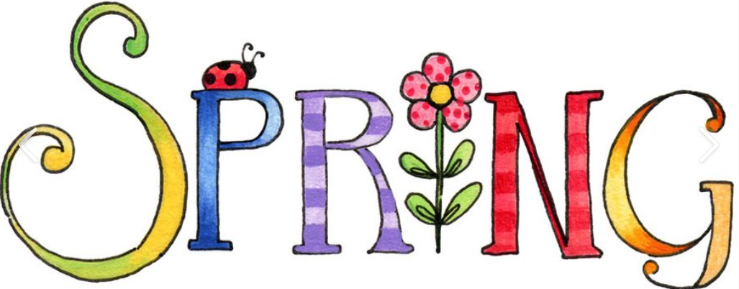
Dear Parents / Guardians,
Welcome back to a new term and a new year. We hope you all had an enjoyable holiday. Below is an overview of the term’s planned work. As always, if there are any topics that you are particularly interested in or have any resources that would support our learning which you would be willing to share, please let us know.

Subject | Detailed Information about our learning | How can you help at home?
English | Reading – we will continue to work on our comprehension skills with a particular focus on inference, prediction and summarising. We will continue our group guided reading sessions each week to encourage discussion and support the development of vocabulary.  Writing –  Poetry – Our focus work will be poetry using portmanteau. We will look at how we are able to ‘blend’ words together to create a new meaning and how language choice can make poetry more interesting to the reader.  Fiction - We will be working on the Pie Corbett traditional tale ‘Nail stew’. During this we will have a strong focus on story structure, descriptive language and including clauses in our writing to create more complex sentences. We will be writing our own versions of this story and exploring the story through drama.  Non-fiction - we will be writing a biography on a key person from Victorian history to support our Topic learning.  Handwriting - we will be continuing to work hard to make sure our writing is the best it can be in all subjects. In our handwriting lessons we will continue to develop our joined handwriting.  Spelling, Punctuation and Grammar – from 9:00-9:30am each day we will have phonics and SPaG lessons focussing on key spelling rules and grammar features to support our writing. | Please consider the following ideas:  • Discuss the focus texts  that are being worked on  and talk about the main  features.  • Join Kington library and visit regularly.  • Encourage your child to  read as much  as possible.  • Ask questions about their books (meanings of words etc.). Some example  questions are included at  the end of the pack.  • Encourage your child to use a dictionary and/or  thesaurus to correct any  spellings that need to be  checked in their writing.
Maths | In our sessions we will be focusing on number and these are the main objectives which we will be covering: -  - Using negative numbers, recognising their place on a number line and using them in contexts such as coordinate grids and graphs.  - Short multiplication and division using partitioning, column method, estimation, regrouping and formal methods.  - Understanding area and scaling before applying our knowledge through worded reasoning problems.  In addition, we will have at least 3 sessions per week focused on times tables and basic maths skills. | Please consider the following ideas:  • Support your child with  their times tables whether that be on ‘Times Tables Rockstars’ or in practical ways at home e.g. counting in steps of 3,4 or 8 as you walk up-stairs  • Be aware and identify  everyday uses of maths  (e.g. money, weighing, time  etc.)  • Practise telling the time.  • Encourage and support your child with homework tasks.
RE | Why do Christians believe Jesus was the Messiah?  As part of the Herefordshire syllabus, we will be finding out this term about Christianity and why Christians believe Jesus is the Messiah. Our aims are as follows;  - To recognise what people expected the Messiah to be like.  - To understand peoples views on the Messiah and explore religious texts to help us understand these views.  - To explore these themes through drama. | Discuss with your child what they have learnt each week and how they feel about it.  Discuss moments in their own lives which have been special to them and think why.
Music | We will be recognising different rhythms and tempo through songs and practical activities each week to develop our musical vocabulary and knowledge. | Talk to your child about what they have learnt each week and see if they want to share any songs they have learnt.
PE | This first half term, we will be learning with a cricket coach on a Tuesday and developing our own dance ready for a performance during our Monday lessons. During the second half term we will be excited to share our dance at the Courtyard followed by Gymnastics and we will also be supported by Mr Fotheringham once a week. | Please wear correct PE kit to school on a Monday and a Tuesday during the first half term.
Computing | We will be learning key new skills and understanding linked to understanding, filming and editing video. We will continue to discuss and understand the importance of our e-safety rules. | If your child has access to a computer, please encourage them to demonstrate the safety rules which we have been discussing in school.
French | We will be continuing to learn French in Year 5 and will be extending our knowledge of everyday phrases and vocabulary. This term we will also make learn how we can describe any pets we have, both written and verbally. | Please encourage your child to teach you the phrases and vocabulary which we explore each week.
Jigsaw/ PSHE | This half term we are beginning to look at the ‘Zones of Regulation’ which we will continue to make a part of our daily school lives in order to support our understanding of emotions and how they can link. | Please discuss with your child the main ideas which have been explored in our weekly sessions. What do they think were the main ideas?
Science | This term, Year 5 are exploring properties and changes of materials. Mrs Guy will be helping the children understand what materials are good thermal conductors/insulators and why before completing a non-chronological report based on their findings. They will also be looking at how materials change and whether these changes are temporary or permanent. | Think about and discuss what you might use at home that conducts heat or acts as an insulator. Why are these items so important to us?
History | We will be learning about The Victorians throughout our Spring term. During this we will cover many topics such as the key figures, the industrial revolution, inventors and inventions and how the Victorian era changed life for us now. We will also be creating our own version of an important Victorian invention which we will invite parents in to see in our ‘museum’. We are also really looking forward to our trip to Blists Hill to bring all our learning together. | Discussing at home the main focus of our learning in school. We may ask for resources (such as newspaper and cardboard) to be brought in but we’ll let you know as we start the planning process.
DT | In our second half term we will be investigating, designing, building and evaluating our own bridges. We will look at the importance of sensible design and choice of materials before building our own bridges in teams to see whose can hold the most weight. | We may ask for resources (such as newspaper and cardboard) to be brought in but we’ll let you know as we start the planning process!
Art | We will be creating our own monotype art work. Leading to this will be using printing, colour and collage to create a piece of work based on the poem ‘Ghost in the Garden’ by Berlie Doherty. | Discuss the work which the children have looked at each week and what they enjoyed about it.
Our class read this term will be ‘Street Child by Berlie Doherty.

Adults in Year 5
We are supported this year by Mrs Welson, Mrs Oliver, Mrs Cadman and Mrs Bachmann. We are also very lucky to have a student teacher, Miss Price, joining us from the University of Worcester.
Homework
Our weekly homework activities give good opportunities for you to talk with your child about their current learning and to support them as they complete their spellings, times tables and reading challenges. They are set on a Friday and should be returned to school by the following Friday.
Reading
In Year 5 daily reading practice remains a focus and is incredibly important. Please find attached to this guide examples of questions which can support the children’s reading at home. In addition to the physical books which the children will bring home they can also access many more books via their Pearson/Bug Club account. Any or all of this type of reading will support their homework reading expectations.
Times Tables
By Year 5, the national expectation is that the children know their tables from X2 through to X12 with fluency and accuracy, to support the children to be able to do this we will continue to use ‘timestable rockstars’ and support our understanding and recall of these tables through practical activities and games.

This term’s events
There are many focuses and themes this term which we will celebrate as a class and a whole school including World Book Day, STEM day, Enrichment morning, NSPCC workshops, poetry workshop, Moving Targets performance, Young Voices and our Blists Hill trip. Remember to look out for more information on these exciting opportunities through letters and our class page of the school website.

As always if there are any questions about any of the information in this guide please don’t hesitate to ask us.
Kind regards,
Mrs Sargeant

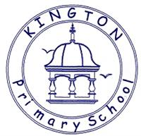

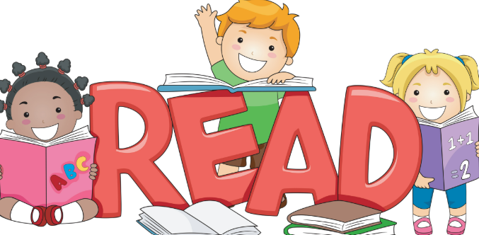
Talking about reading at home
Fiction
Q What sort of person is……? What makes you think that?
Q What is your opinion of this character?
Q How do you know (character) was feeling: happy, sad, scared, excited?
Q ……was feeling upset. How do you know? Find two pieces of evidence
Q What choice would you have made?
Q Why do you think ………is acting in this way?
Q Why do you think ……… said “…………………..” ?
Q What do you think …meant when he/she said “……………”
Q What does this tell you about what he/she was thinking/feeling?
Q How do you know ……… and …………were enemies? Best friends? Find 2 pieces of evidence.
Q Which of these characters do you feel closest to? Why?
Q Why do you think the author describes the setting as “………”
Q Who is your favourite character? Why?
Q Look at the author’s description of ….. Why do you think the author wrote the description in this way?
Q Why do you think the author chose to use a short sentence in this part of the story?
Q Did you enjoy this story? Why?
Q What, in your opinion, was the most exciting part of the story, explain your answer in as much detail as you can.
Q What is your opinion of the ending the author chose?
Q Can you think of an alternative ending?
Q Does this story have a moral/message?
Q Which words or phrases create suspense in this piece of writing?
Q How does this text compare to other books that you have read by the same author?

Non-Fiction
Q What is the information on the back of a story book called?
Q Where will you find an index? In which order will you find these words?
Q Can you explain what information you will find in a glossary?
Q Where will you find the contents in a non-fiction book?
Q What are the differences between fiction and non-fiction?
Q What information does this diagram tell you?
Q Why do you think the author chose to use arrows/lines in this diagram?
Q How does the way the title has been written encourage you to read this report?
Q What is the difference between a non-chronological report and an explanation?
Q Is this advertisement a good example of a persuasive text? If so, Why? Why not?
Poetry
Q Which words rhyme in this poem?
Q Which adjectives have been used to describe……?
Q Which genre best describes this story? Explain using evidence from the text
Q What type of text is this? How do you know this?

