September 2025 – Class 5

Dear Parents / Guardians,
Welcome back to the new school year. We hope you all had an enjoyable summer holiday. Below is an overview of the term’s planned work. As always, if there are any topics that you are particularly interested in or have any resources that would support our learning which you would be willing to share, please let us know.

Subject | Detailed Information about our learning | How can you help at home?
English | Reading – we will be developing our comprehension skills with a particular focus on vocabulary and retrieval. We will have group guided reading sessions each week to encourage discussion and support the development of vocabulary as well as a comprehension lesson once a week.  Writing –  Poetry – Our focus work will be poetry using personification. We will look at how we are able to create an image of Autumn using our poem in an effective way though language choice.  Fiction - We will be working on the Pie Corbett traditional tale ‘the Legend of Randwick’. During this we will have a strong focus on story structure, descriptive language and including clauses in our writing to create more complex sentences. We will be writing our own versions of this story and exploring the story through drama.  Non-fiction - we will be writing a set of instructions which will link to our class story of ‘When the Sky Falls’ by Phil Earle. Throughout this we will focus on language choice, adverbials of time and ow the layout of instructional writing differs to other genres they are familiar with.  Spelling, Punctuation and Grammar – from 9:10-9:40am each day we will have phonics and SPaG lessons focussing on key spelling rules and grammar features to support our writing. | Please consider the following ideas:  • Discuss the focus texts  that are being worked on  and talk about the main  features.  • Join Kington library and visit regularly.  • Encourage your child to  read as much  as possible.  • Ask questions about their books (meanings of words etc.). Some example  questions are included at  the end of the pack.  • Encourage your child to use a dictionary and/or  thesaurus to correct any  spellings that need to be  checked in their writing.
Maths | In our sessions we will be focusing on number and these are the main objectives which we will be covering: -  - Decimal fractions, helping the children make links between fractions, decimal numbers and becoming confident in different ways to represent these.  - Becoming confident in using money within different equations.  - Negative numbers and how these are represented.  In addition, we will have at least 3 sessions per week focused on times tables. | Please consider the following ideas:  • Support your child with  their times tables whether that be on ‘Times Tables Rockstars’ or in practical ways at home e.g. counting in steps of 3,4 or 8 as you walk up-stairs  • Be aware and identify  everyday uses of maths  (e.g. money, weighing, time  etc.)  • Practise telling the time.  • Encourage and support your child with homework tasks.
RE | What does it mean if Christians believe God is holy and loving?  As part of the Herefordshire syllabus, we will be finding out this term about Christianity and what it means if Christians believe God is holy and loving. Our aims are as follows;  - Pupils will learn about what Christians believe God is like.  - They will explore key texts from the Bible.  - To explore these themes through drama. | Discuss with your child what they have learnt each week and how they feel about it.  Discuss moments in their own lives which have been special to them and think why.
Music | We will be exploring time signatures and performing together to understand rhythm, pulse, timbre and tempo. Once we have gained a stronger understanding of these elements, we will be moving on to performing rhythms expressively. | Talk to your child about what they have learnt each week and see if they want to share any songs they have learnt.
PE | This first half term, we will be developing our confidence in our football and netball skills. We look forward to seeing these skills shine for any children who chose to taken place in the Mitchel Hamer and Selena Cup competitions this year. During the second half term we will begin to work on our Moving Targets dance and will also be supported by a sports coach once a week. | Please wear correct PE kit to school on a Tuesday and a Thursday in the first half term. New PE days will be sent out for the second half term when they have been decided.
Computing | We will be learning key new skills and understanding linked computer networks, systems and sharing information. We will also start to build up an understanding of vector drawings and how we can create and use shapes to build an image. We will continue to discuss and understand the importance of our e-safety rules. | If your child has access to a computer, please encourage them to demonstrate the safety rules which we have been discussing in school.
French | We will be continuing to learn French in Year 5 and will be extending our knowledge of everyday phrases and vocabulary. This term we will also make learn how we can describe our families and the date. | Please encourage your child to teach you the phrases and vocabulary which we explore each week.
Jigsaw/ PSHE | During the first half term we will be looking at ‘being me in my world’ where the children will be understanding how to be a responsible citizen of their school and country. We will also be working to set individual goals for the year ahead both in and out of school. In the second half term we will then look at celebrating differences and how we can always show respect to others. | Please discuss with your child the main ideas which have been explored in our weekly sessions. What do they think were the main ideas?
Science | This term, Year 5 are exploring animals and their life cycles. Mrs Guy will be helping the children understand differences between animals, mammals, insects and amphibians and about reproduction facts too. They will also be looking at the Earth and Space topic next half term to deepen their understanding of the different planets around us. | Discuss what other cycles do we see in nature?  Is your child able to explain what they have learnt in that lesson?
History | In our topic work this term, Year 5 will be looking at World War 2. During this topic we explore a variety of aspects including the cause of the outbreak of war, rationing, evacuation, women in war, food and the Holocaust. These topics will be put across in an appropriate and child friendly way but if you have any concerns, please contact me. | Discussing at home the main focus of our learning in school. Can the children talk about how their lives would be different during the war? Can they name any other big changes that happened during this time?
DT | In our second half term we will be creating gingerbread! Cooking is always lots of fun and helps the children learn more about food hygiene and being safe in a kitchen. | No need to bring anything in for this but the children may be inspired to make their own gingerbread creations at home. What can they create?
Art | We will be understanding more about typography and how different text types and font have a different impact on the viewer. The children will then be creating their own map and choosing the most appropriate typography for each area of the island they have created. | Discuss the work which the children have looked at each week and what they enjoyed about it.
Our class read this term will be ‘When The Sky Falls’ by Phil Earle.

Adults in Year 5
We are supported this year by Mrs Welson, Mrs Oliver and Miss Williams, with Mrs Guy teaching our Science lessons.
Homework
Our weekly homework activities give good opportunities for you to talk with your child about their current learning and to support them as they complete their spellings, times tables and reading challenges. They are set on a Friday and should be returned to school by the following Friday. The children all have spelling frame and TTRS logins that are useful in supporting their homework each week.
Reading
In Year 5 daily reading practice remains a focus and is incredibly important. Please find attached to this guide examples of questions which can support the children’s reading at home. In addition to the physical books which the children will bring home they can also access many more books via their Pearson/Bug Club account. Any or all of this type of reading will support their homework reading expectations.
Times Tables
By Year 5, the national expectation is that the children know their tables from X2 through to X12 with fluency and accuracy, to support the children to be able to do this we will continue to use ‘timestable rockstars’ and support our understanding and recall of these tables through practical activities and games.

This term’s events
There are many focuses and themes this term which we will celebrate as a whole. Remember to look out for more information on these exciting opportunities through letters and our class page of the school website.

As always if there are any questions about any of the information in this guide please don’t hesitate to ask us.
Kind regards,
Mrs Sargeant

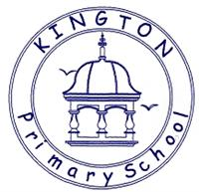

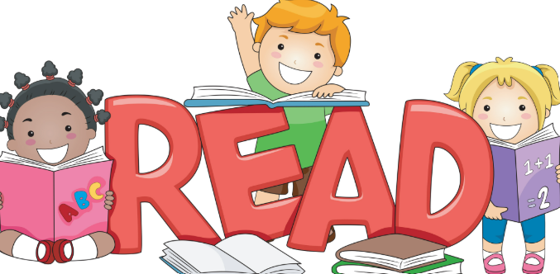
Talking about reading at home
Fiction
Q What sort of person is……? What makes you think that?
Q What is your opinion of this character?
Q How do you know (character) was feeling: happy, sad, scared, excited?
Q ……was feeling upset. How do you know? Find two pieces of evidence
Q What choice would you have made?
Q Why do you think ………is acting in this way?
Q Why do you think ……… said “…………………..” ?
Q What do you think …meant when he/she said “……………”
Q What does this tell you about what he/she was thinking/feeling?
Q How do you know ……… and …………were enemies? Best friends? Find 2 pieces of evidence.
Q Which of these characters do you feel closest to? Why?
Q Why do you think the author describes the setting as “………”
Q Who is your favourite character? Why?
Q Look at the author’s description of ….. Why do you think the author wrote the description in this way?
Q Why do you think the author chose to use a short sentence in this part of the story?
Q Did you enjoy this story? Why?
Q What, in your opinion, was the most exciting part of the story, explain your answer in as much detail as you can.
Q What is your opinion of the ending the author chose?
Q Can you think of an alternative ending?
Q Does this story have a moral/message?
Q Which words or phrases create suspense in this piece of writing?
Q How does this text compare to other books that you have read by the same author?
Non-Fiction
Q What is the information on the back of a story book called?
Q Where will you find an index? In which order will you find these words?
Q Can you explain what information you will find in a glossary?
Q Where will you find the contents in a non-fiction book?
Q What are the differences between fiction and non-fiction?
Q What information does this diagram tell you?
Q Why do you think the author chose to use arrows/lines in this diagram?
Q How does the way the title has been written encourage you to read this report?
Q What is the difference between a non-chronological report and an explanation?
Q Is this advertisement a good example of a persuasive text? If so, Why? Why not?
Poetry
Q Which words rhyme in this poem?
Q Which adjectives have been used to describe……?
Q Which genre best describes this story? Explain using evidence from the text
Q What type of text is this? How do you know this?

Weekly Spellings
Group 1 - First half term
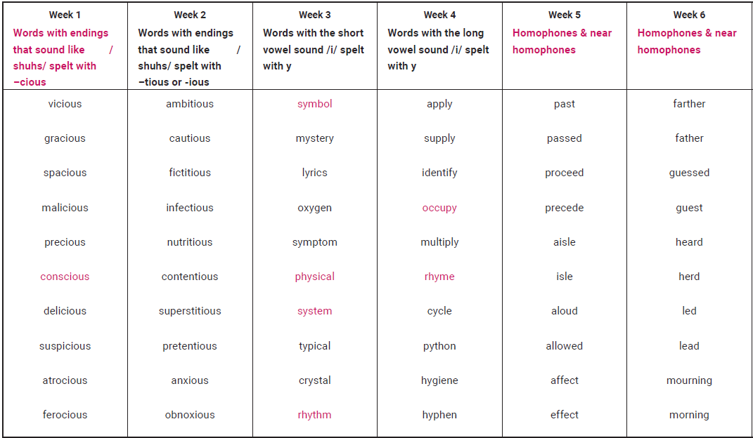
Second half term
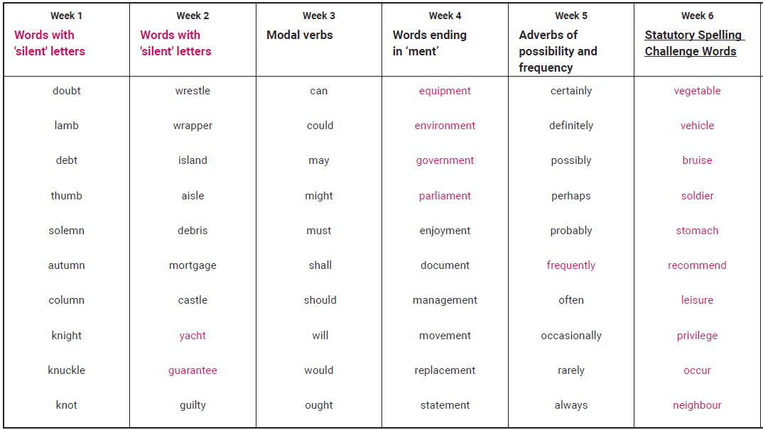
Any weeks not covered by the plans above will be given words we’re finding tricky!
Group 2 and 3’s spellings will be based on their morphology and snip lessons each week.

