Summer 2026 – Class 4WG
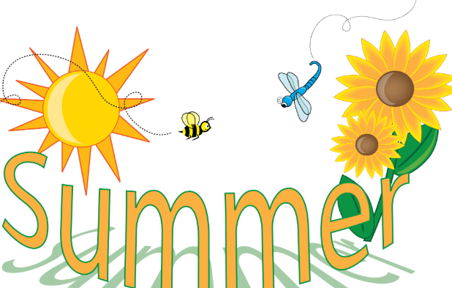
Key question: What makes an enjoyable journey?
Dear Parents / Guardians,
Welcome back to a new term and a new year. We hope you all had an enjoyable holiday. Below is an overview of the term’s planned work. As always, if there are any topics that you are particularly interested in or have any resources that would support our learning which you would be willing to share, please let us know.
Over the summer term, our topic will be focused on exploring journeys. We will learn about the main features of a river and investigate why rivers are so important. We will locate the main rivers within each continent on a world map, honing our map skills and discover the mountain ranges where they begin and find out which sea/ocean they flow into. In particular, we will examine our very own River Arrow but also consider how journeys by water benefitted the invading Vikings and Saxons.

Subject | Areas of learning | Activities to support at home
English  Mrs Welson & Mrs Guy | Reading – we will continue to work on our comprehension skills with a particular focus on answering questions about characters, settings and the main events. The children are heard to read by an adult in Y4 at least once a week, but it is key that they also read at home at least 3 times a week. Reading at home can be from our ‘book band’ physical books or e-books via Bug Club in addition to any of the books which the children enjoy reading for their own pleasure. Please sign their homework records to reflect their reading at home.  Writing – This term we will complete our work linked to ‘ Voices in the Park’ by Anthony Browne which we will be exploring through drama activities, vocabulary discussions and looking at the structure of the text. Our aims are to use this text to help us to tighten up on key grammatical techniques and vocabulary choices through close examination of extracts from the story and to inspire our narrative writing that will really take shape after half term.  Handwriting - we will be working very hard to secure our letter formation and start joining in as many pieces of work as we can. The children will be working on the size and flow of their letters.  Spelling, Punctuation and Grammar – We will continue to work in our appropriate daily spelling groups and work on focus spellings each week. We use Bug Club and Spelling Frame online resources to support our spellings and reading in class but both resources can be accessed at home with our individual passwords. | Please consider the following ideas:  • Discuss the focus texts  that are being worked on  and talk about the main  features.  • Join Kington library and visit regularly.  • Encourage your child to read as much  as possible.  • Ask questions about their books (meanings of words etc.). Some example  questions are included at  the end of the pack.  • Encourage your child to use a dictionary and/or  thesaurus to correct any  spellings that need to be  checked in their writing.
Maths  Mrs Welson & Mrs Guy | Alongside our permanent focus on the times tables we will also be exploring division so that we can use this number operation accurately with questions that might not have remainders but equally might have remainders. We will be looking to develop our understanding of how multiplication and division are linked. Also, we will be exploring symmetry, co-ordinates and equivalent fractions.  We will continue to work on times tables daily alongside ‘Mastering Number at KS2’. This term in mastering number, we will be continuing to achieve our ‘going for gold’. ‘Gold’ is when we know all 144 facts from the times table. The children already know lots of these, so the focus will be on learning the tricky facts that are harder to recall. All of our multiplication work will be supporting us as we head towards our national assessment in June. The MTC tests our recall of multiplication facts and our children will be ready and familiar with the practicalities of the test and website such as TTRS, Hit the Button and times tables.co.uk all help with this preparation.  Home - Times Tables Rock Stars  Hit the Button - Quick fire maths practise for 6-11 year olds  Multiplication Tables Check - 2025 - Timestables.co.uk | Please consider the following ideas:  • Support your child with  their times tables whether that be on ‘Times Tables Rockstars’ or in practical ways at home e.g. counting in steps of 3,4 or 8 as you walk up-stairs or playing X games.  • Be aware and identify  everyday uses of maths  (e.g. money, weighing, time  etc.)  • Helping practise number  bonds & facts.  • Practise telling the time.  • Encourage and support your child with homework tasks.
Computing  Mrs Guy | We will be looking at how to edit images and why images may be edited. We will also be looking at fake images before moving on to look at data collection and analysing data. | Alongside our coding activities we will continue to reinforce key safety rules for using technology and highlighting the need to let adults know of any concerns. On our school website we have useful parent guides for different Apps and websites that could support discussions at home.
Science  Mrs Guy | States of Matter.  We will begin this term by exploring changes of state by making chocolate crispy cakes. We will then look at evaporation and the water cycle before exploring rivers. We will look at the features of a river and how they are formed before spending time looking more closely at the River Arrow. | Go for a walk in your local area and see if you can spot any features of a river.
RE  Mrs Welson | Christianity  This term we are learning about the importance of Pentecost for Christians and how it links to the story of Easter. How do Christians mark this Bible story?  Our focus will then move onto the key question: How and why do people mark the significant events of life? This will be an opportunity to look at both Christianity and Hinduism and looking for similarities and differences. | Discuss with your child what they have learnt each week and how they feel about it. Do they have questions?  Discuss moments in their own lives which have been special to them and think why.
History & Geography  Mrs Welson | As described at the top of this guide: As we move on from our Egyptian topic following our trip to Swansea, we will be learning more about the geography of rivers. We will be learning about our local river and considering how this river flows throughout different towns and villages that we might know before taking our topic wider to consider the importance of water for invaders described as Vikings and Saxons. | Using suggested websites to help you to understand more about these topics.  Discussing at home the main focus of our learning in school.
Art/DT  Mrs Welson | In art we will be honing our still life skills so that we can record images when visiting the River Arrow and the local area.  In the second half term we will have 2 DT projects to work on:  Seasonal foods where we will explore where our vegetables come from and how they are farmed.  Pencil cases: we will practise sewing stitches and explore fastenings before creating our own pencil case. | Discuss the work which the children have looked at each week and what they enjoyed about it.  Discuss their plans for their own pencil case– what features will they need to include?
PE  Mrs Welson, Mrs Guy & Mr Fothringham | PE is on Monday and Friday for the first half term  On a Monday we will be working on our athletics skills exploring different throwing, jumping and running events.  On a Friday we will be developing our rounders skills, looking at how to accurately throw and catch a ball and batting skills. | Please wear correct PE kit to school on a Monday and a Friday.
Modern Foreign Languages  French  Mrs Welson | My family.  We will be looking at family members and how to ask if you have any brothers and sisters.  We will then move on to looking at ‘In the Classroom’ and learning new vocabulary and phrases linked to that. | Please encourage your child to teach you the phrases and vocabulary which we explore each week.
Music  Mrs Welson & Mrs Walker | With Mrs Walker we will be continuing to learn the ukulele. We will develop our music appreciation skills, awareness of important chords and start to recognise music notation. We will invite families to a class performance this term to celebrate our progress this year. | Talk to your child about what they have learnt each week with our instrument.
Jigsaw/ PSHE  Mrs Guy | We will be working through our weekly sessions on the unit ‘relationships’ where we will look at what makes a ‘healthy friendship’. Through this work we will also focus on the feeling of jealousy and how this can impact on our relationships. | Please discuss with your child the main ideas which have been explored in our weekly sessions. What do they think were the main ideas?

Adults in 4W
Year 4 are supported by Mrs Wood or Miss Griffiths during the mornings; Miss Gardiner also supports in Year 4 during the week. We work with Mrs Walker on a Tuesday afternoon.
Homework
Homework gives a good opportunity for your child/children to work with you and discuss their learning. In Year 4, the homework set will be for English and maths every week with topic work tasks as and when appropriate. Homework will be set on Friday and the due date for homework is the following Friday. Remember that a stamp is awarded for every week where homework is completed and returned with those who have achieved at least 4 stamps in the half term will be added to a prize draw.
Reading
The children will be reminded every day that they can change their reading books if needed and this should be done independently. Please let one of us know if the children are not changing their books successfully. At the back of this pack are some good example questions you could use while reading with your child/children, to help deepen their understanding and comprehension.
Times Tables
Times tables are important in being a fluent and successful mathematician. We will continue to practise these in school daily. We strongly encourage you to practise these as part of your homework and focus on the ones that your child/children find most difficult. Remember that children are now expected to learn their tables up to 12x12 with an assessment during the summer term. There are lots of good games/songs on the Class 4 section of the school website. Every child also has access to TimesTables Rock Stars.
This term’s events
There are many focuses and themes this term which we will celebrate as a whole school including Sports day and Enrichment with Key Stage 2 also taking part in our summer show and local walks. Remember to look out for more information on these exciting opportunities through letters and our class page of the school website.
As always if you have any questions or queries, please do not hesitate to ask either via the school office or through the Y4 email Y4Teacher@kington.hereford.sch.uk
Many thanks,
Mrs A Welson and Mrs C Guy
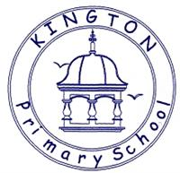
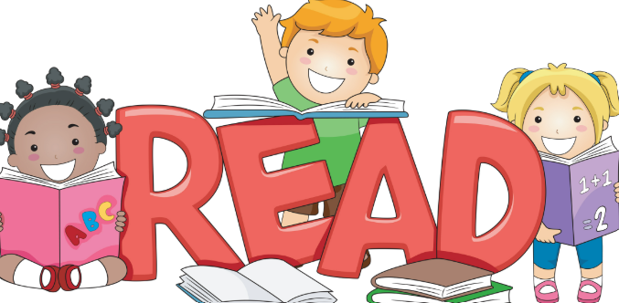
Talking about reading at home
Fiction
Q What sort of person is……? What makes you think that?
Q What is your opinion of this character?
Q How do you know (character) was feeling: happy, sad, scared, excited?
Q ……was feeling upset. How do you know? Find two pieces of evidence
Q What choice would you have made?
Q Why do you think ………is acting in this way?
Q Why do you think ……… said “…………………..” ?
Q What do you think …meant when he/she said “……………”
Q What does this tell you about what he/she was thinking/feeling?
Q How do you know ……… and …………were enemies? Best friends? Find 2 pieces of evidence.
Q Which of these characters do you feel closest to? Why?
Q Why do you think the author describes the setting as “………”
Q Who is your favourite character? Why?
Q Look at the author’s description of ….. Why do you think the author wrote the description in this way?
Q Why do you think the author chose to use a short sentence in this part of the story?
Q Did you enjoy this story? Why?
Q What, in your opinion, was the most exciting part of the story, explain your answer in as much detail as you can.
Q What is your opinion of the ending the author chose?
Q Can you think of an alternative ending?
Q Does this story have a moral/message?
Q Which words or phrases create suspense in this piece of writing?
Q How does this text compare to other books that you have read by the same author?

Non-Fiction
Q What is the information on the back of a story book called?
Q Where will you find an index? In which order will you find these words?
Q Can you explain what information you will find in a glossary?
Q Where will you find the contents in a non-fiction book?
Q What are the differences between fiction and non-fiction?
Q What information does this diagram tell you?
Q Why do you think the author chose to use arrows/lines in this diagram?
Q How does the way the title has been written encourage you to read this report?
Q What is the difference between a non-chronological report and an explanation?
Q Is this advertisement a good example of a persuasive text? If so, Why? Why not?

Poetry
Q Which words rhyme in this poem?
Q Which adjectives have been used to describe……?
Q Which genre best describes this story? Explain using evidence from the text
Q What type of text is this? How do you know this?



