Summer Term 2026 – Class 5
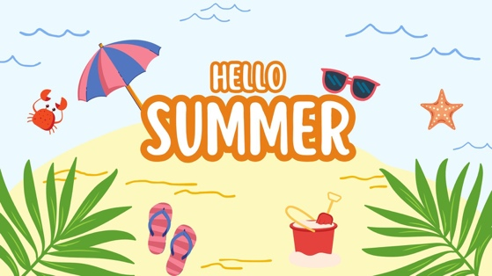
Dear Parents / Guardians,
Welcome back to a new term. We hope you all had an enjoyable Easter holiday. Below is an overview of the term’s planned work. As always, if there are any topics that you are particularly interested in or have any resources that would support our learning which you would be willing to share, please let us know.

Subject | Detailed Information about our learning | How can you help at home?
English | Reading – we will continue to work on our comprehension skills with a particular focus on inference, prediction and summarising. We will continue our group guided reading sessions each week to encourage discussion and support the development of vocabulary.  Writing –  Fiction - We will be working on ‘The True Story of the Three Little Pigs’ by Jon Scieszka. During this the children will be using all the fantastic writing features they have developed to re-write the story to make it even more exciting.  Non-fiction – We will be looking at persuasive texts, their features and what makes them effective. We will then write our own persuasive letter about whether we should or should not wear uniform. It’s always interesting seeing which the children choose.  Spelling, Punctuation and Grammar – from 9:00-9:30am each day we will have phonics and SPaG lessons focussing on key spelling rules and grammar features to support our writing. | Please consider the following ideas:  • Discuss the focus texts  that are being worked on  and talk about the main  features.  • Join Kington library and visit regularly.  • Encourage your child to  read as much  as possible.  • Ask questions about their books (meanings of words etc.). Some example  questions are included at  the end of the pack.  • Encourage your child to use a dictionary and/or  thesaurus to correct any  spellings that need to be  checked in their writing.
Maths | In our sessions we will be focusing on number and these are the main objectives which we will be covering: -  - Recognising and understanding improper and mixed number fractions.  - Multiplying fractions.  - Finding a fraction of a quantity.  - Comparing fractions.  - Finding equivalent fractions.  - Finding the equivalent fraction and decimal.  In addition, we will have at least 3 sessions per week focused on times tables in our Mastering Number sessions. | Please consider the following ideas:  • Support your child with  their times tables whether that be on ‘Times Tables Rockstars’ or in practical ways at home e.g. counting in steps of 3,4 or 8 etc as you walk up-stairs  • Be aware and identify  everyday uses of maths  (e.g. money, weighing, time  etc.)  • Practise telling the time.  • Encourage and support your child with homework tasks.
RE | Christians and how to live: ‘What would Jesus do?’  As part of the Herefordshire syllabus, we will be finding out this term about Christianity and how Christians choose the ways they live. Our aims are as follows;  - Where do Christians find out about what Jesus did?  - Why do Christians think it is wise to follow Jesus’ teachings?  - What was Jesus’ sermon on the mount about?  - How do some Christians follow Jesus’ example in caring for those in need? | Discuss with your child what they have learnt each week and how they feel about it.  Discuss moments in their own lives which have been special to them and think why.
Music | We will be learning all about singing in rounds as part of a group, making sure we keep to the correct beat and tempo as the others in my group, as well as the other groups too. We will also be starting to learn the songs for our Key Stage 2 show. | Talk to your child about what they have learnt each week and see if they want to share any songs they have learnt.
PE | This first half term, we will be developing our Athletics skills ready for sports day on a Tuesday and developing our tennis skills on a Thursday. In the second half term, we will be continuing to work on our athletics skills ready for sports day and improving our badminton skills on a Monday and working with a sports coach from community coaching on a Friday. | Please wear correct PE kit to school on a Tuesday and Thursday during the first half term and a Monday and Friday during the second half term.
Computing | We will be looking at data systems, how these work and how we might use them in our daily lives.  We will be continually discussing how to stay safe online and encouraging the children to show safe practice both in school and at home. | If your child has access to a computer, please encourage them to demonstrate the safety rules which we have been discussing in school.
French | We will be continuing to learn French in Year 5 and will be extending our knowledge of everyday phrases and vocabulary. This term we will also make learn how we can describe our home, both written and verbally. | Please encourage your child to teach you the phrases and vocabulary which we explore each week.
Jigsaw/ PSHE | During this term we will be exploring different ways we can stay healthy including discussing smoking, alcohol, emergency first aid and body image. We will then move on to look at relationships with a strong focus in being safe as part of an online community. | Please discuss with your child the main ideas which have been explored in our weekly sessions. What do they think were the main ideas?
Science | This term, Year 5 are exploring forces. Mrs Guy will be helping the children the effects friction and resistance have on how objects move and the amount of force needed to move things. They will also explore the impact gears, pulleys and levers have on force. In the second half term, Year 5 will be looking at animals including humans. During this unit we will be discussing puberty and the changes children may expect as they grow up. | Discuss any questions that may arise from our science sessions, particularly any questions about puberty that your child may have. Please feel free to discuss this with Mrs Sargeant or Mrs Guy.
Topic | We will be exploring North and South America, looking at their climates, location and how their location impacts life in these countries. This then moves on to looking at the Maya civilisation, how life was for the Maya people, aspects of life today that were influenced by Maya times and how the Mayas were able to survive and thrive in their environments. | Discussing at home the main focus of our learning in school. Are the children able to discuss any aspects of life today that may have come from Maya times?
DT | In our first half term we will continue to look at developing strong bridges and what is required for this. We will then move on to designing and building our own bridges in teams to meet a design criteria. | Continue to discuss your child’s work with them, asking which aspects they enjoy and see if they can explain the different features of bridge building.
Art | We will be exploring famous set designer Rae Smith before planning, designing and making our own set design. | Discuss the work which the children have looked at each week and what they enjoyed about it. We will ask for boxes to be brought in to build their set within during the second half term.
Our class story this term will be ‘Oh Maya Gods’ by Maz Evans.

Adults in Year 5
We are supported this year by Mrs Welson, Mrs Oliver and Mrs Cadman. We are also very lucky to have a student teacher, Miss Wictome, joining us from the University of Worcester.

Homework
Our weekly homework activities give good opportunities for you to talk with your child about their current learning and to support them as they complete their spellings, times tables and reading challenges. They are set on a Friday and should be returned to school by the following Friday.
Reading
In Year 5 daily reading practice remains a focus and is incredibly important. Please find attached to this guide examples of questions which can support the children’s reading at home. In addition to the physical books which the children will bring home they can also access many more books via their Pearson/Bug Club account. Any or all of this type of reading will support their homework reading expectations.
Times Tables
By Year 5, the national expectation is that the children know their tables from X2 through to X12 with fluency and accuracy, to support the children to be able to do this we will continue to use ‘timestable rockstars’ and support our understanding and recall of these tables through practical activities and games.
This term’s events
There are many focuses and themes this term which we will celebrate as a whole school including our Enrichment mornings, Sports Day and Key Stage 2 show. Remember to look out for more information on these exciting opportunities through letters and our school website.

As always if there are any questions about any of the information in this guide please don’t hesitate to ask us.
Kind regards, Mrs Sargeant

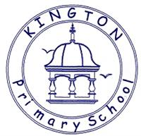

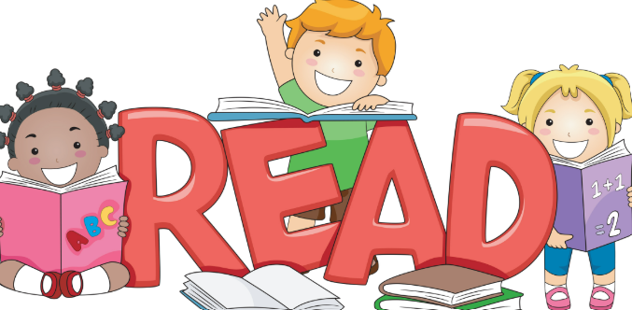
Talking about reading at home
Fiction
Q What sort of person is……? What makes you think that?
Q What is your opinion of this character?
Q How do you know (character) was feeling: happy, sad, scared, excited?
Q ……was feeling upset. How do you know? Find two pieces of evidence
Q What choice would you have made?
Q Why do you think ………is acting in this way?
Q Why do you think ……… said “…………………..” ?
Q What do you think …meant when he/she said “……………”
Q What does this tell you about what he/she was thinking/feeling?
Q How do you know ……… and …………were enemies? Best friends? Find 2 pieces of evidence.
Q Which of these characters do you feel closest to? Why?
Q Why do you think the author describes the setting as “………”
Q Who is your favourite character? Why?
Q Look at the author’s description of ….. Why do you think the author wrote the description in this way?
Q Why do you think the author chose to use a short sentence in this part of the story?
Q Did you enjoy this story? Why?
Q What, in your opinion, was the most exciting part of the story, explain your answer in as much detail as you can.
Q What is your opinion of the ending the author chose?
Q Can you think of an alternative ending?
Q Does this story have a moral/message?
Q Which words or phrases create suspense in this piece of writing?
Q How does this text compare to other books that you have read by the same author?
Non-Fiction
Q What is the information on the back of a story book called?
Q Where will you find an index? In which order will you find these words?
Q Can you explain what information you will find in a glossary?
Q Where will you find the contents in a non-fiction book?
Q What are the differences between fiction and non-fiction?
Q What information does this diagram tell you?
Q Why do you think the author chose to use arrows/lines in this diagram?
Q How does the way the title has been written encourage you to read this report?
Q What is the difference between a non-chronological report and an explanation?
Q Is this advertisement a good example of a persuasive text? If so, Why? Why not?
Poetry
Q Which words rhyme in this poem?
Q Which adjectives have been used to describe……?
Q Which genre best describes this story? Explain using evidence from the text
Q What type of text is this? How do you know this?

Weekly Spellings
Group 1
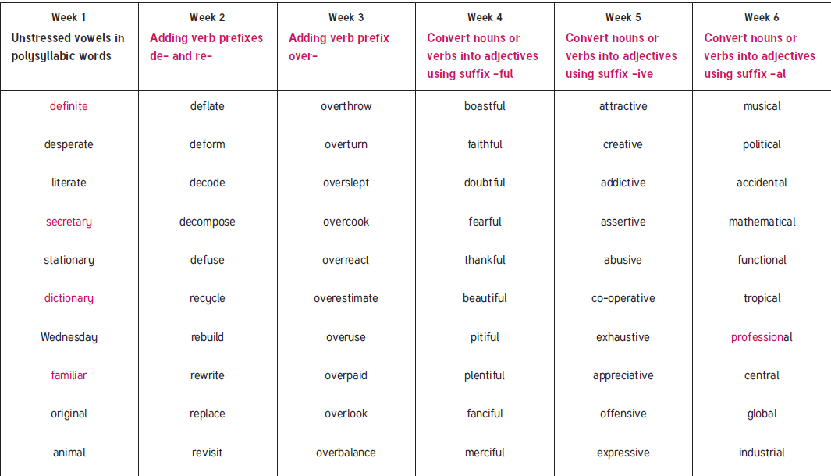
Group 2 and 3’s spellings will be based on their phonics lessons each week.

