Literacy  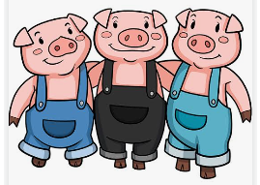  Our story this term is The Three Little Pigs.  We will be writing…  - character descriptions  - questions for the characters  - using vocabulary from our text  - a sequence of sentences  In addition to this we will be learning about plural and singular words. | Phonics  - Revision of Phase 3 tricky words  (reading then spelling)  - Revision of Phase 4 which focuses on reading and spelling words with adjacent consonants, such as; frog, plan, next & street  - Start Phase 5, learning alternative spellings for graphemes already known; wh, ph, ay, a-e, ea & e-e  Example words; wheel, dolphin, play, cake, sea & these | Maths  We start the term by revising work covered in Reception.  Then move on to look at comparison of quantities and measures;  Using words such as tallest, longest, longer than, taller than, heavier than, lighter than, larger, fewer, equal, etc…  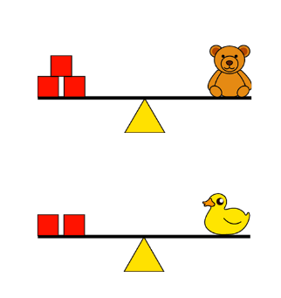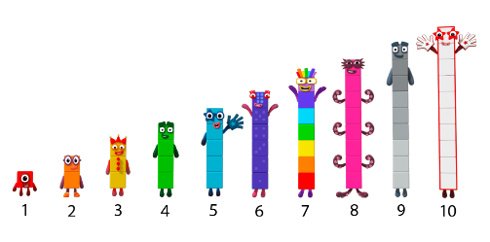  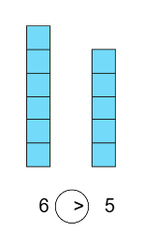  Children will be introduced to the following symbols;  < > and =  In addition to this we will start to look at the composition of the numbers 0-5. This work will link to work covered in Reception.  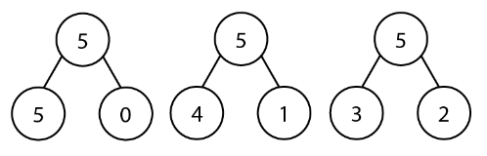
Geography  We are learning all about the weather.  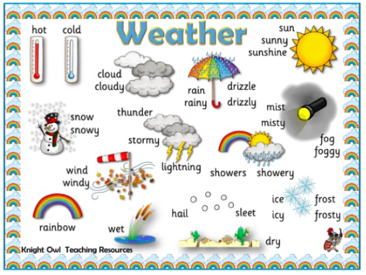 | 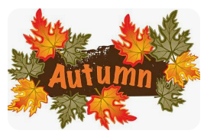  Autumn Term 2026  Year 1
PE  PE Days this term will be Thursday and Friday.  We will be focusing on  - running (changing speed), jumping, throwing and catching with increased control and coordination.  - Developing spatial awareness  - Simple group games  - Exercising safely, recognising how the body feels after exercise. | Music  We will be exploring pulse and rhythm.  The QR code will take you to one of the songs that we will be learning.   | Science  We are learning all about animals.  - Naming body parts  - Comparing animals  - Sorting animals into groups  - Living and non-living  Vocabulary; body part words, mammals, reptiles, fish, birds, insects etc..
ART  We will be exploring spirals in art this half term.  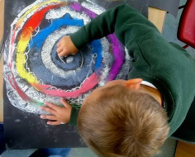 |   PSHE  In our PSHE session we will focus on  - Keeping ourselves and others safe  - Belonging  - Our rights and responsibilities  - Rewards & feeling proud    - Consequences | Dates  Y1 PE Days Thursday & Friday  Indivudual photographs 13th October  Flu vacines 15th October  Enrichment dates 20th October & 1st December  Parents Evening 20th & 21st October  Year 1 Maths workshops  - 10th November 2-3pm  - 12th November 9.15-10.15

